**GardenPal**

**Harry Thomas**

**C16455964**

Submitted in partial fulfilment of the requirements for the degree of

**BSc in Business Computing**

Technological University Dublin

Year 4

Supervisor: Audrey Jennings

Second Reader: Neil O’Connor

April 2020

**Acknowledgements**

There are a few people I would like to thank because without them this project would not have been possible. I would like to express my sincerest gratitude towards those whose have assisted me throughout the year.

Firstly, I would like to thank my supervisor Audrey Jennings who has set aside a lot of time to make sure I got through this project. Audrey gave me direction as to where I should be aiming with this project, always answering any queries I had and providing constructive criticism throughout the year. I am especially thankful for the weekly meeting which really kept me on my toes. Without Audrey, I would not have got this far.

I would also like to thank my second reader, Neil O’Conner, who provided invaluable outside perspective and made me think about the app from a user’s perspective which helped me massively while developing this project.

I would also like to thank my parents for all their support throughout my four years in college, without them I would not be here. I want to thank my dad especially, who I consulted many times over the year for gardening advice. Also, thanks to my mam for her support and making me countless dinners for the past four years.

I want to give a special thanks to Eoghan Mahar and my uncle David. Without Eoghan, I would not have had the idea to create a gardening app. He came up with a great idea that addresses a real issue. David provided unrivalled support and helped me in any way he could all year.

**Table of Contents**

**Objectives of GardenPal**............................................................................5

**Requirements capture and Analysis**.........................................................6

**Business Actors and Workers**………………………………………………6

**Requirements Analysis.**……………………………………………………..6

**ERD Diagram..**............................................................................................7

**Database Design.**……………………………………………………………….8

**Use Case Diagram**…………………………………………………………….12

**Technology Diagram**………………………………………………………….13

**Technology, Libraries and API’s**.............................................................14

**Functional Requirements…….**………………………………………………17

**UI Design**………………………………........................................................23

**Welcome Screen….**……………………….….……………………………24

**Login Screen.**………………………………………………………………25

**Register Screen**……………………………………………………………26

**Home Screen….**……………………………………………………………27

**New User Popup**…………………………………………………………...28

**Menu Popup**………………………………………………………………..28

**Garden Info.**………………………………………………………………..29

**Edit Garden Info**……………………………………………………………30

**Add Plants**………………………………………………………………….32

**Recommended Plants Screen**………………………………………….….33

**Algorithm for selecting recommended plants..**……………………………35

**Full Sun, Partial Shade and Full Shade Screens….**….….…………………36

**Browse by Type Screen.**……….……………………………………….….37

**Algorithm for the suitability of a plant..**………………………………..…..38

**View Plant Screen**………….………………………………………………39

**My Plants Screen**……….………………………………………………….40

**View My Plant Screen**……………….……………………………………..41

**Deciding what season a plant requires maintenance**…….……………….42

**Maintenance Planner Menu Screen**……………………………………….43

**Grass Planner Screen..**…………………………………………………….44

**Algorithm for how often grass should be cut**……………………………..45

**Calendar Screens**………………………………………………………….46

**Select a time Screen….**……………………………………………………47

**Parsing weather data**……………………………………………………...48

**Create a Job Screen**……………………………………………………….50

**Plant Maintenance Screen**………………………………………………...51

**My Jobs Menu Screen**……………………………………………………..52

**Jobs created by me Screen**….….…………………………………………53

**View My Job Screen**……….………………………………………………54

**Seasonal Jobs Screen**…..…………………………………………………56

**View Plant Job Screen.**….…………………………………………………57

**Other Jobs Screen**…………………………………………………………58

**Implementation Issues and Resolutions**...............................................59

**Test Plan**...................................................................................................60

**Conclusion**................................................................................................66

**Objectives of GardenPal**

The main objective of GardenPal was to develop an app for people who are new to gardening so they can plan their garden maintenance and make informed choices about what plants they should add to their garden.

The idea for this project came from my part time job as a landscaper. Customers constantly ask such questions as… When do I start/stop cutting grass in the year? How often should I cut my grass? How do I know if a plant is suitable for my garden? How do I take care of this plant? One customer suggested the idea of an app that could answer all these questions. With my father being a respected landscaper for the past 20 years, I felt that I could develop this app, provide the users with highly accurate information and take the stress out of gardening.

Soil is the most important part of a garden, it effects how fast grass grows and a vital factor in whether a plant will survive or not. So, I spent a lot time researching the different soil types in Ireland and their characteristics.

**Requirements Capture and Analysis**

**Business Actors and Workers**

There is only one user of GardenPal, there is no separation between them and the business specific users. This single user is represented by the user table in the firebase Database, their email and password are also stored in the firebase authenticator for login purposes.

**User**

The user of GardenPal has access to every function of the app as they are the only type of user. They can perform all of the CRUD functions (Create, Read, Update, Delete). They can input their garden details, browse plants, add plants to their garden, add maintenance to plants and make their own jobs.

**Requirements Analysis**

In my requirements analysis, I spoke to family members, neighbours and most importantly customers of the family landscaping business about the process they go through when selecting plants for their garden. I asked if they know which plants and suitable for their garden based on its characteristics. I also asked did they how to properly maintain plants and grass and when to care for them.

I got some great feedback. The main issues people had been not knowing which plants would suit their garden and they didn’t know how and when to take care of them. Another issue people had was when to start and stop cutting their grass in the year.

This reinforced my idea as I have provided a place where users can plan their maintenance without having to know a lot about their garden and gardening.

**Entity Relationship Diagram**

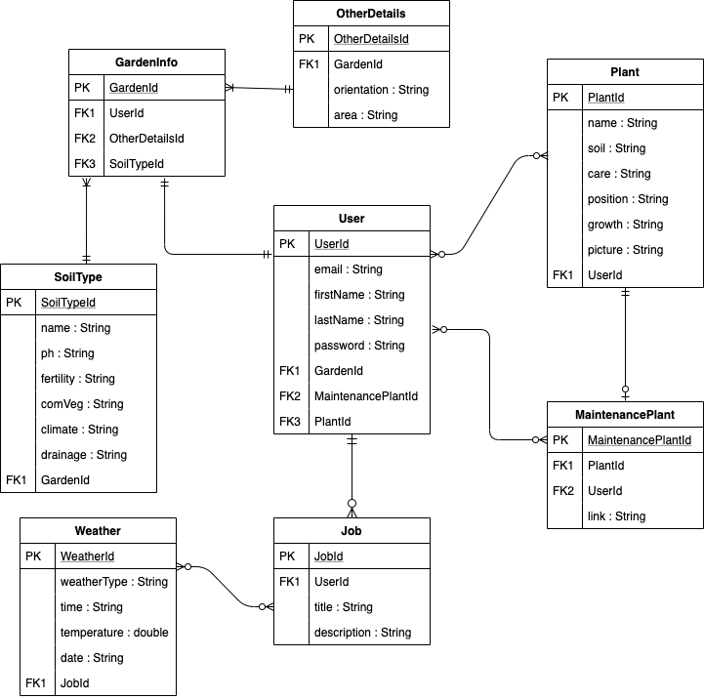

**Database Design**

GardenPal uses **Firebase Real-time** **database** to store all relevant information from the app and uses **Firebase Authentication** to authenticate the users of the app.

**Firebase Authentication**

When the user completes registration in GardenPal the Firebase Authenticator stores the users email and password. The user’s password is never displayed to the database administrator for security purposes. Each user also has a unique u ID (UID) which is used to save data unique to each user.

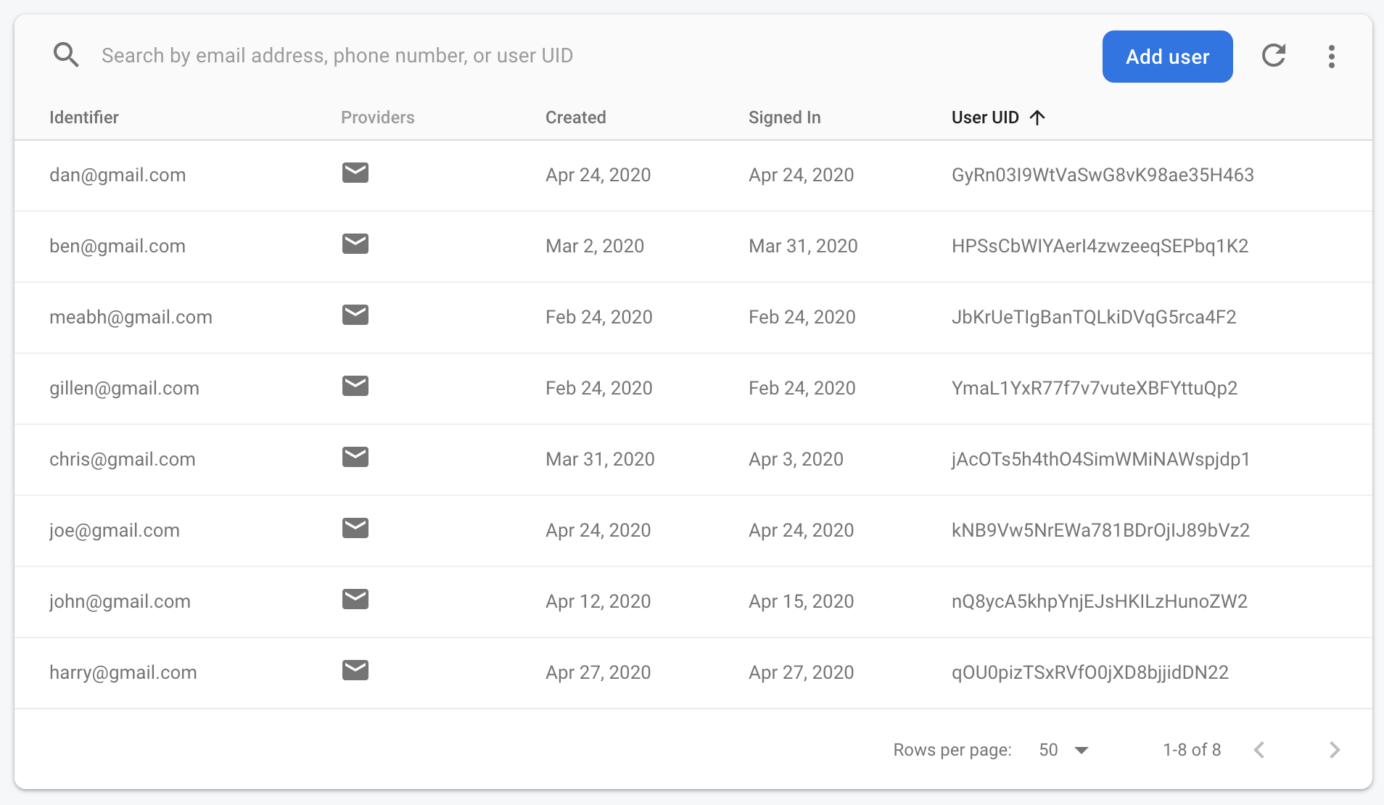

**Firebase Real-time Database**

The real-time database is used to store data about the user’s jobs, plants and garden information. Every time the user saves something their UID is attached to it so data is unique to them.

These are the tables stored in the Database…

**Users**

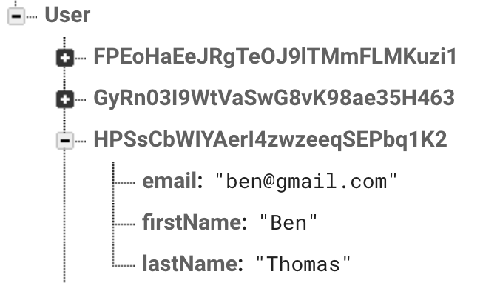

The User UID

**SoilType**

This is the UID of the User

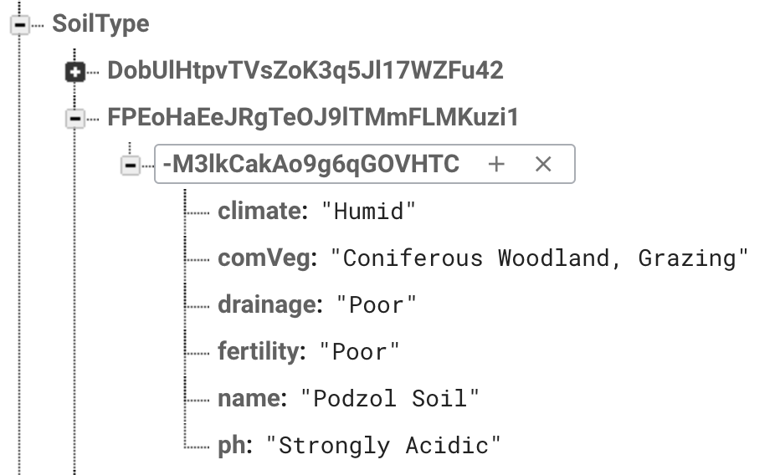

This is the ID of the soil type

**OtherDetails**

The UID of the User

The ID of other details

**Note:** The data stored in both the 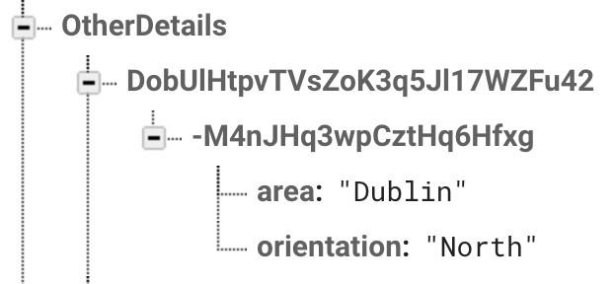**SoilType** and **OtherDetails** combine to make up a user’s Garden Info.

**MyPlants**

If a User saves adds a plant to ‘My Plants’ the plant is stored here.

The Users UID

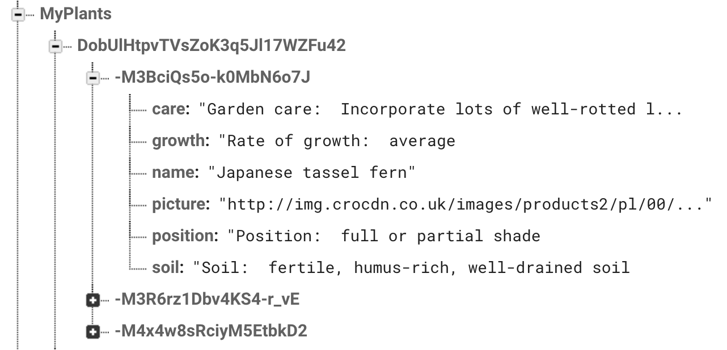

Plant pictures are stored as URL’s in the DB

The ID of the Users Plant

**MaintenancePlant**

When the user clicks ‘Add to My Jobs’ while viewing one of their plants, a new object called a MaintenancePlant is made.

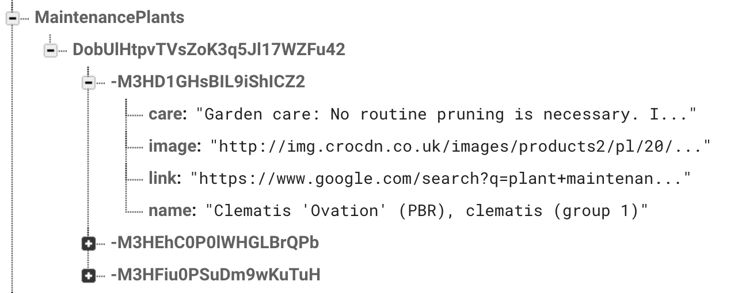

ID of the MaintenancePlant

The Users UID

**Job**

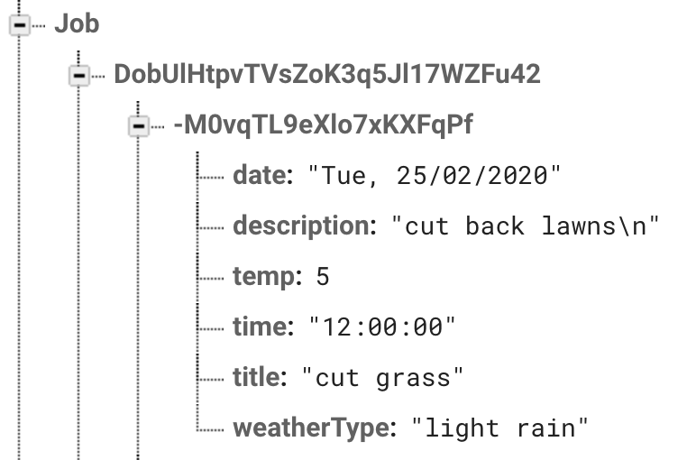

ID of the job the user has created

The Users UID

**Use Case Diagram**

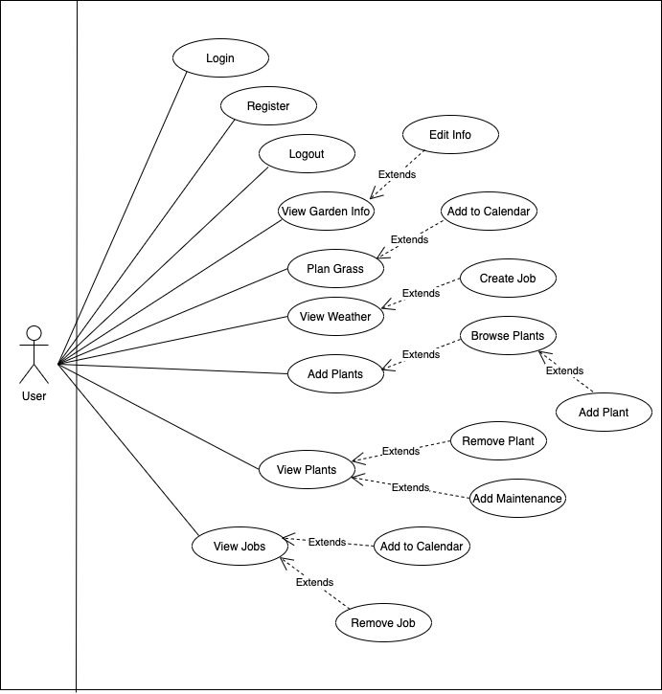

**Technology Diagram**

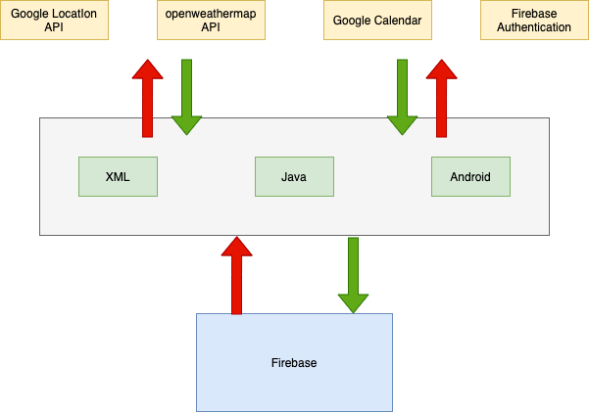

**Technologies, Libraries and API’s**

**Android SDK**



The entire project was developed using Android Software Development Kit (SDK) within Android Studio. I used an Android phone to test the app instead of using an emulator as it does not have a GPS to get location. Emulators are also slow and not usually an accurate representation of what the app will look like on a phone.

**Firebase Authentication**



To authenticate the user, the app uses firebase’s authentication feature to check the users details when logging in. The app uses the authenticator to let users to auto sign in also. I used this as the app is using the real-time database so it can sync the user’s details.

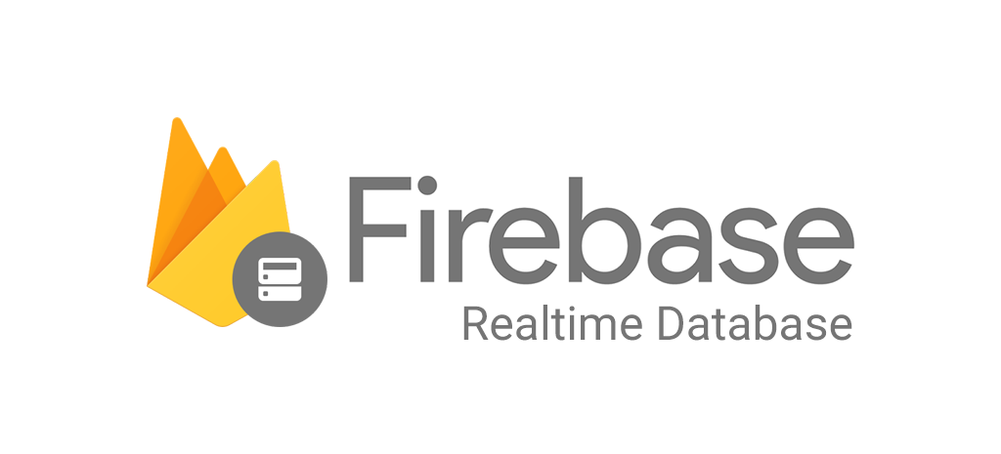

**Firebase Real-time database**

I decided to use firebase real time database as it is cloud based storage so the user can access their data at any time. The app stores user details which are also linked to the authenticator. Other information such as jobs and soil type.

**Google Location Services API**

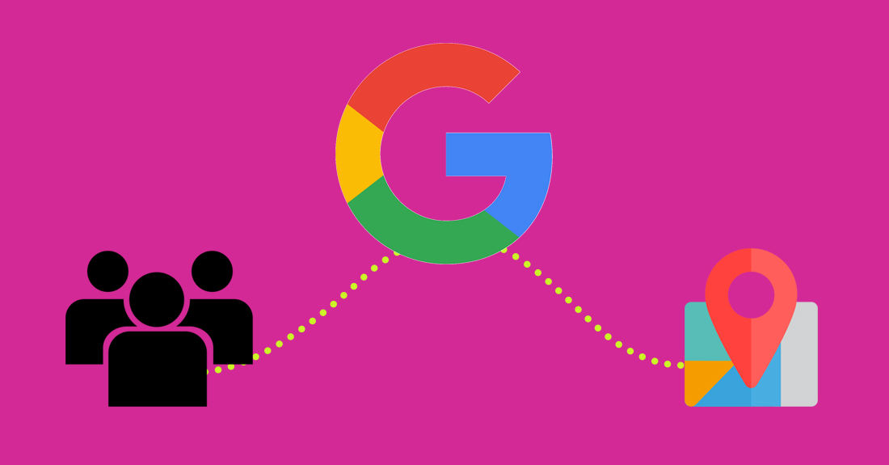

The app uses Googles location API to get the users longitude and latitude from the phones location service. I did this as I needed the weather data to be accurate to where the user is. Ideally, I would have got the users Eircode, but you can’t pass it into the weather API.



**OpenWeatherMap API**

I used the openweathermap API to get weather forecast for 5 days at 3 hour intervals. I would have liked to use the 16-day forecast at 1 hour intervals but I would have to pay for it.

**GIT**

I used GIT for version control as it is very easy to use with Android Studio. Through- out the course of the year I added, modified and remove parts of the app through GIT. I often had to roll back to previous versions if something went wrong. The main benefit for GIT for me was the ability to access my project on multiple devices as I had trouble with my laptop through- out the year.

**Volley**



Volley is an HTTP library that I used to connect to the weather API. I chose to use Volley as it easy to use and fast for small HTTP requests. Since I wasn’t requesting too much data, it was ideal.

**Picasso**

Picasso is an image downloading and caching library in android. I used this to load pictures of plants in their ImageView. The reason I used Picasso is because the app loads images from URLs and Picasso is the best and easiest way to do this.

**Google Calendar**



GardenPal needs access to a calendar so the user can save jobs to their calendar. Instead of making one in the app I decided to use the google calendar already installed on the user’s phone. The reason I didn’t code a calendar directly on the app was so the user can have all their jobs and events etc. in the one place to avoid confusion.

**Functional Requirements**

A functional requirement refers to what the application actually does as opposed to what the users expects.

|  |  |  |  |
| --- | --- | --- | --- |
| Category | Title | Requirement | Justification |
| Register | User registers with all necessary details | User can register an account in GardenPal and will be brought to the home page where they will be prompted to input their garden details | User can create an account |
| Register | Register Failure | User will be given an error message to say their details are incorrect and will ask them to input the details again | Inform the user that their details are wrong |
| Login | User Logs in with email and password | User successfully logs in with their credentials saved in Firebase Authentication, they will then be directed to the GardenPal home page | User can use all the functions of the app after login |
| Login | Login Failure | User will be shown an error message if their details are incorrect or there is an error logging in, they will then have input there details again | Inform the user that their details are wrong |
| Logout | Logout | User can successfully logout of the app | The user needs to protect their details and private information by logging out |
| Information | Information | User can click on the black “i” icon to view a popup with information about GardenPal | If the user is unsure of what all the features do they can read about them here |
| Garden Info | My Garden Info | Here the users can view the details about their garden and can click a button to edit these details | This displays vital information about the user’s garden that the app needs to make plant recommendations |
| Garden Info | Edit Garden Details | User can find what soil type based on their location and select what orientation their garden is | The app needs this info to accurately make plant suggestions based on the characteristics of their garden. |
| Maintenance Planner Menu | Grass Planner | User can view info on when to start and stop cutting grass and how often to cut it. They can add all the cuts in the season their calendar. | In order for a user to properly plan their grass maintenance they need to know when to start/stop and how often they should cut it |
| Maintenance Planner | Select a Time | The user views the weather forecast and select a time and a day to create a job | In order for a user to properly plan a job they need to know that the weather is suitable for the desired time |

|  |  |  |  |
| --- | --- | --- | --- |
| Maintenance Planner | Create a Job | Here the user can input the title of the job and the description of the job | A job needs a title so the user can identify it and a description so they know what has to be done |
| Maintenance Planner | Add To My Jobs | User clicks on this button to add the job to the database and their list of jobs | This is so the job is added to the database with the user’s unique ID so when the user views their jobs it only displays jobs they have made. |
| My Plants | My Plants | User can view all the plants they have added their garden | Allows the user to view the plants in their garden without having to go find them every time in the ‘Add Plants’ section |
| My Plants | Delete Plant (red bin icon) | User clicks on this red bin icon to delete the specific plant from their list of plants | If the user no longer wants this plant in their garden they have the option to remove it |
| My Plants | View Plant | The user clicks on a plant and it opens a page where they can view all the details about that plant | The user needs to view information about the plant to see how to care for it. |
| My Plants | Add to My Jobs | The user clicks this button and will automatically add it to their jobs | When the user presses this button it automatically creates a job for it so the user does not have to input the details of the job themselves |

|  |  |  |  |
| --- | --- | --- | --- |
| Add Plants | Add Plants Menu | Here the user can browse plants, view more information on plants and add them to ‘My Plants’ | In order to for a user to add maintenance for plants they need to add plants to ‘My Garden’ |
| Add Plants | Browse by suitability | Here GardenPal analyses the user garden info and the plants info and presents the user with a list of plants suitable for their garden | Users who don’t know much about gardening may want the app to recommend plants to them instead of searching for suitable plants themselves |
| Add Plants | Browse by shade | Users can view plants based on how much sunshine the plant requires | Users may have areas in their garden with different levels of shade and want to browse plants suitable for these different areas |
| Add Plants | Browse by category | User can view all plants GardenPal based on the type of plant | Some user may just want to browse all available plants and find plants they like and check if they are suitable themselves |
| Add Plants | View Plant | When a user is scrolling through plants they can tap on a plant to view more information about it | When a user is scrolling through plants they may want to check the characteristics of the plant and see how to care for that plant |

|  |  |  |  |
| --- | --- | --- | --- |
| Add Plants | Add to My Plants | When a user in viewing a plant, and decide they want it in their garden, they tap this button and it will add it to their garden. | A user may want to add a certain plant to their garden or already has this plant in their actual garden |
| Add Plants | Search Plants | When the user is browsing plants, they can click the search icon and search for whichever plant they want. | A user may already know what plant they are looking for and don’t want to scroll through all the plants looking for it |
| My Jobs | Browse by Jobs you created | The user can view the jobs they created themselves. | The user may want to view theirs jobs to see what has to be done and add that job to the calendar or delete it |
| My Jobs | Browse jobs by season | The user can view the jobs that have to be done based on what season it is | This separates out what maintenance has to be done for each plant the user has added based on the season of the year they require maintenance |
| My Jobs | Browse jobs with no specified time | This is where the jobs with no specified time for maintenance will appear | Some jobs may not a specified time to complete maintenance but the user still needs to view what has to be done |

|  |  |  |  |
| --- | --- | --- | --- |
| My Jobs | View Created by me job | The user can view a job they created themselves, they see the time, date, weather and what has to be done | The user may create many jobs and needs to go back and see what has to be done or add the job to their calendar |
| My Jobs | View Plant Maintenance Job | When the user adds maintenance for a job they can view that to see what has to be done. If they want more information they can click a link which will bring them to a google search of maintenance for that plant | The user needs to view plant to see what has to be done. If they want to know more caring for the plant they can view more info online |
| My Jobs | Add to Calendar | User can click this button to open the calendar and create a job at a time that suits them | The user may like to have all their jobs and events on the one calendar |
| My Jobs | Mark as done | User presses the green tick on the job to mark it as done | User may want to remove the job as it has been completed and want to declutter their jobs list |

**UI Design**

GardenPal handles a lot of data, so an easy to use UI is a vital part of the App. The main goal was to design an easy to use, bright and aesthetically pleasing UI, that would work well for both advanced and inexperienced users.

Some of the guidelines that I followed include:

**Guidance:** GardenPal is mainly targeted towards people who don’t know much about gardening and want somewhere to start. When a user completes registration, they are guided through the process of inputting garden information and selecting plants.

**Usability:** A lot of time went into making the UI work in a way where the user can do what they want to do in as few clicks as possible.

**Reassurance:** Anytime the user clicks a button, they are told what is happening or if there is an error. This is to avoid confusion and reassure the user of what they are doing.

A lot of time was dedicated to implementing the UI. I researched the best practises on UI design and downloaded many other gardening apps to get ideas on how I would implement the UI. I preformed many tests on the UI to make sure it worked as expected.

A key factor in making the UI as usable as possible was outside perspective. I gave the app to family members and friends to see could they use it without me having to walk through it with them. Any issues they had or if they had to ask me how to do something, it was noted.

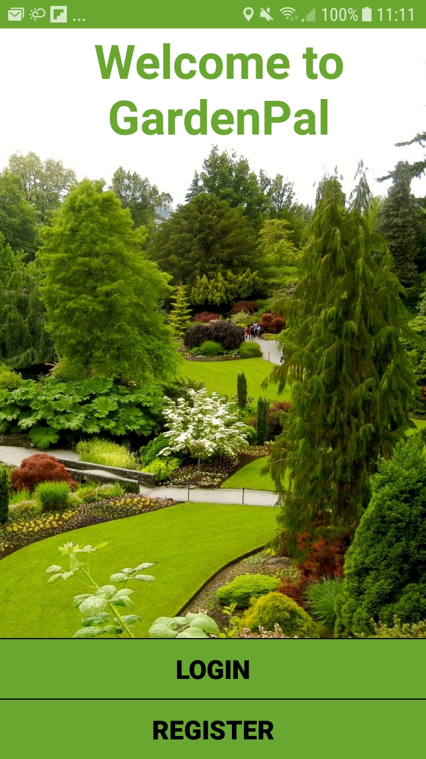**Welcome Screen**

This is the first screen the user is greeted with when they open the app. It has 2 buttons:

**Login:** This button directs the user to the Login Screen, so the user can sign in to their account. If the user is returning to the app and have previously logged in, they do not have to input their credentials again, they are automatically forwarded to the home screen.

**Register:** This button directs the user to the register page where they can sign up to use GardenPal

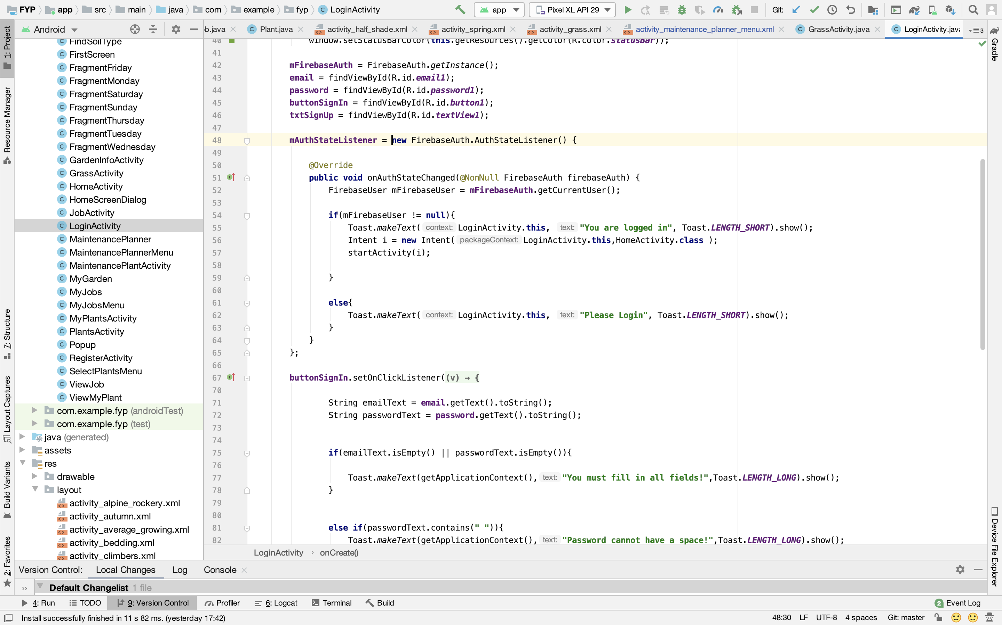

**Login Screen**

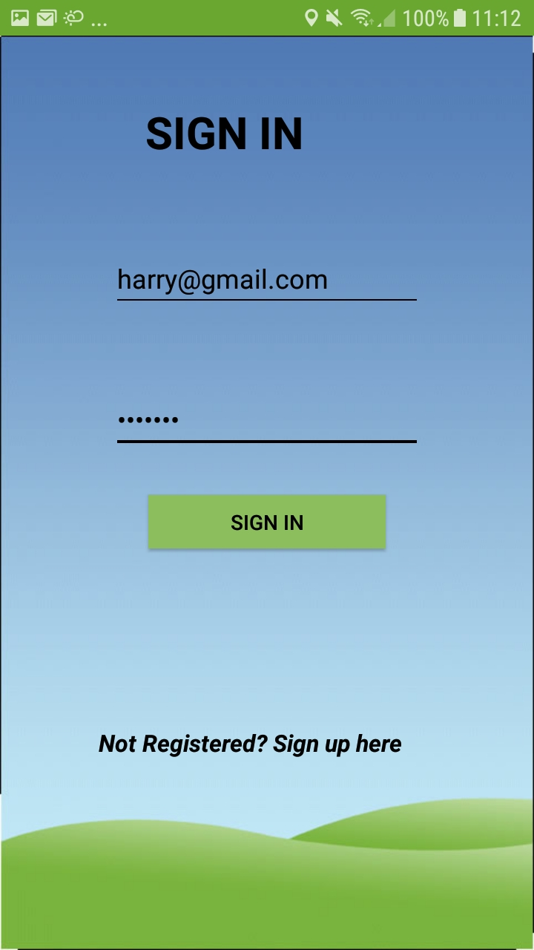

Here the user can sign into their account using their email and password and then tap the sign in button to be directed to the Main Menu. When the user inputs their credentials, the credentials are sent to the firebase authenticator to make sure the user exists.

If the user has not signed up yet, they can tap on the ‘Not Registered? Sign Up’ text and they will be directed to the register screen to sign up.

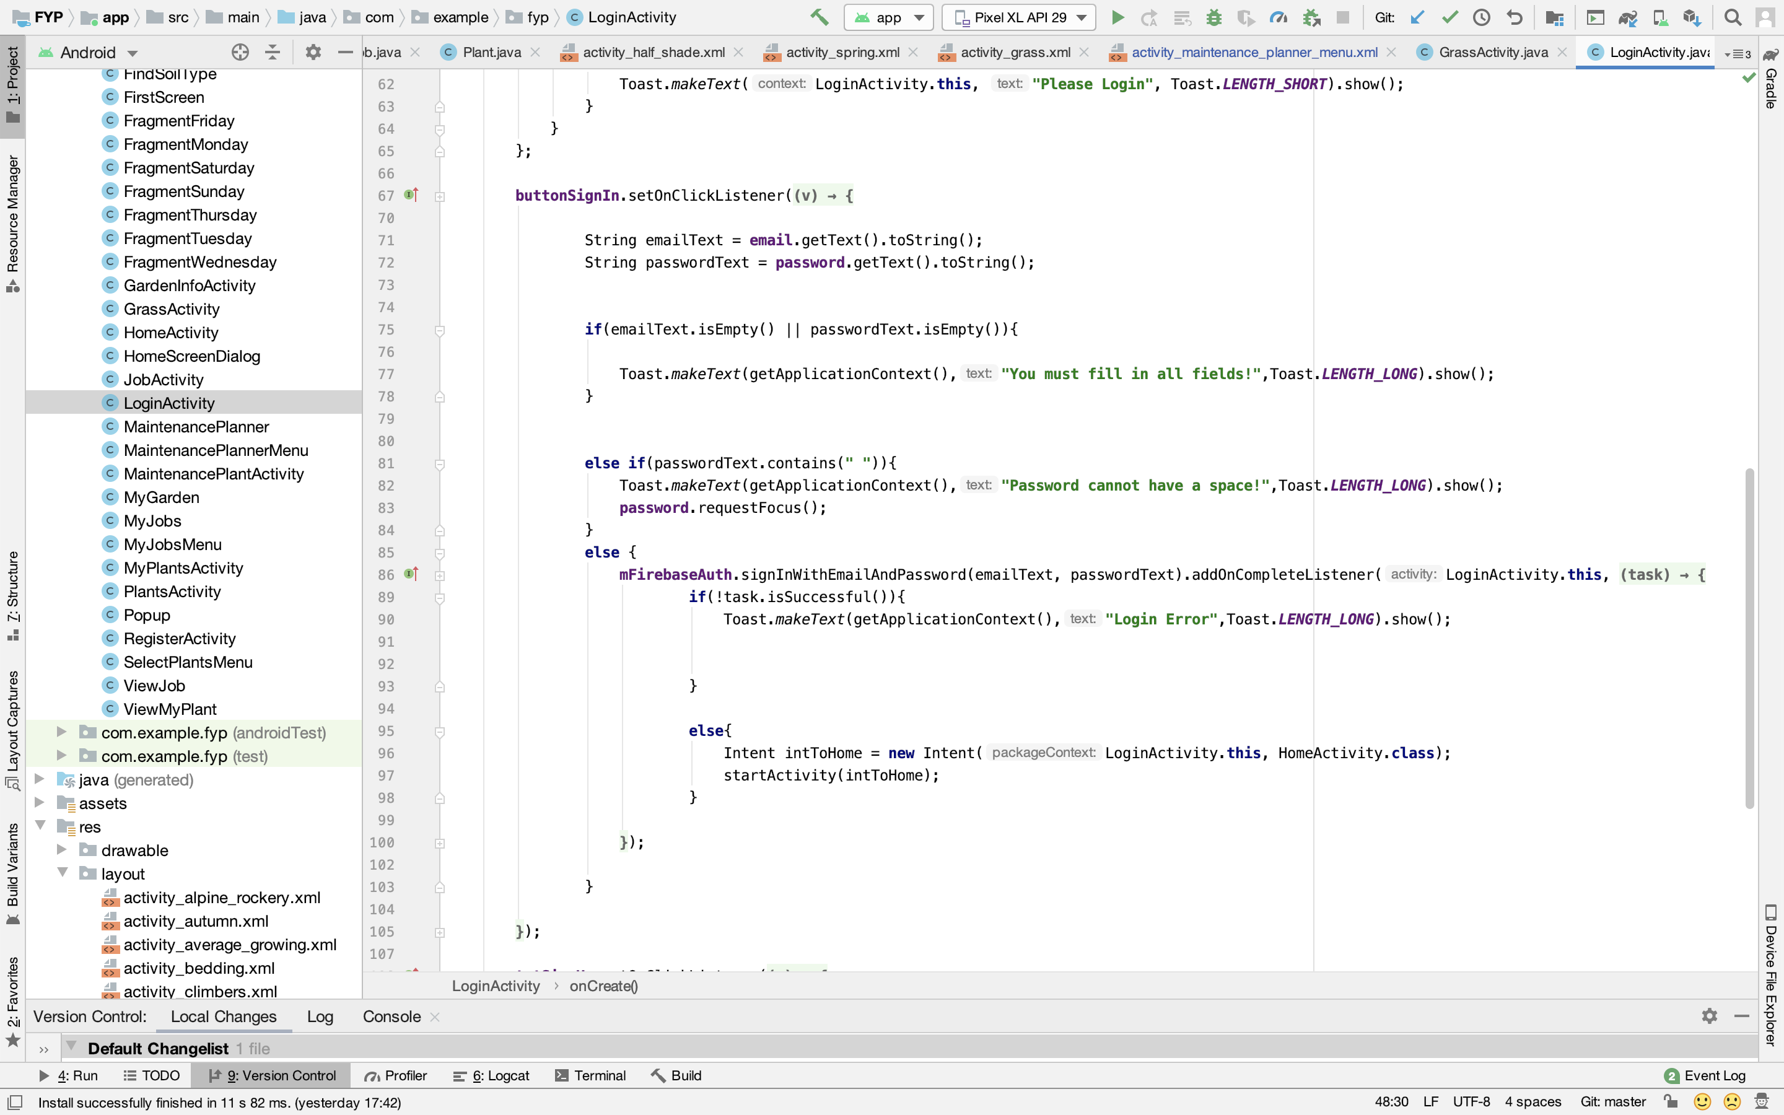

**Register Screen**

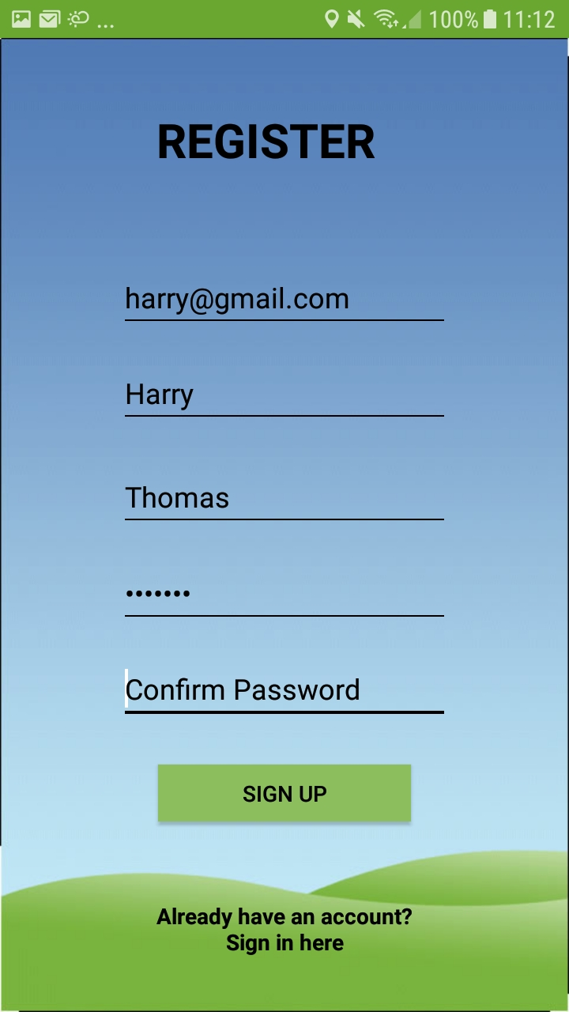

On this screen, the user can sign up to use GardenPals services. They input their email, first name and last name.

They also have to input a password and then confirm it to make sure that they don’t make any mistakes inputting their password.

If they already have an account they can click the ‘Already have an account? Sign in here’ text and they will be directed to the Login Screen.

There is error checking in place to make sure the password has no spaces and is over 6 characters.

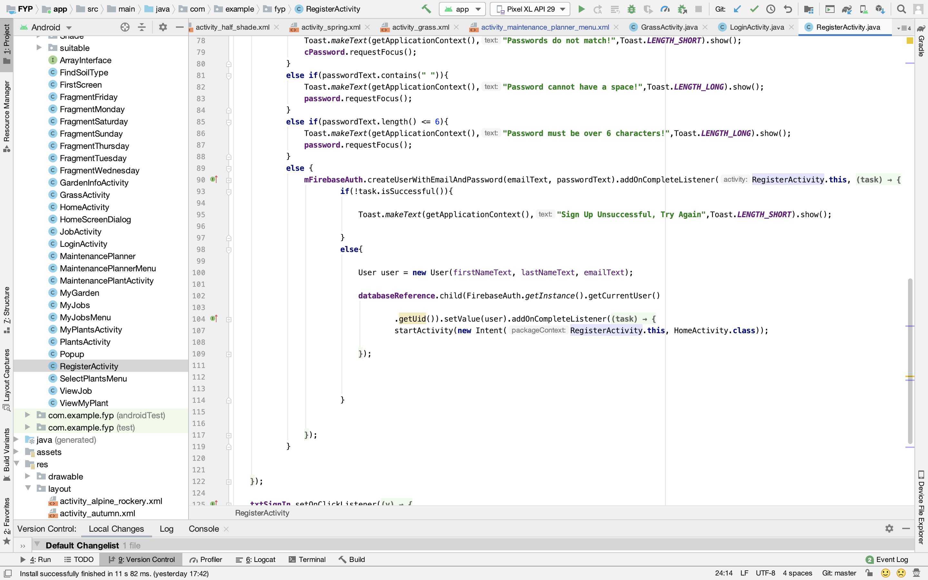

**Home Screen**

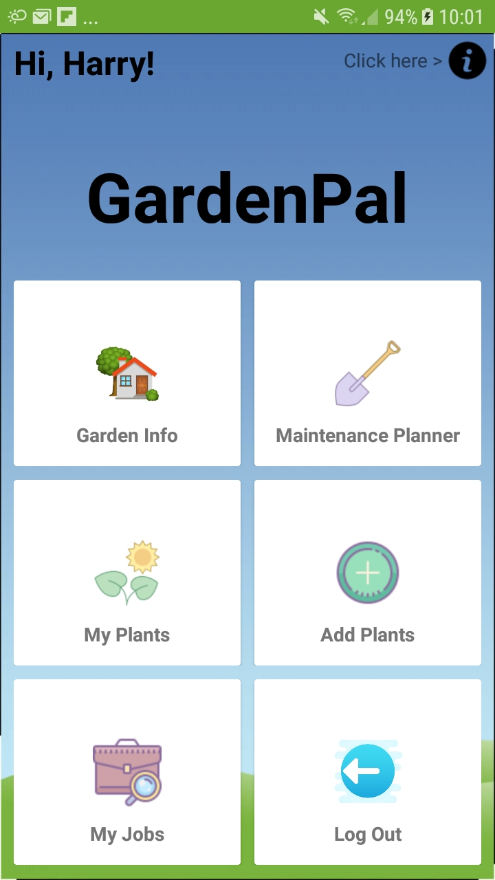

This the main menu screen where the user can navigate to any part of the app they wish. It displays a welcome message to the user by sending a query to firebase authentication to the get first name of the current user.

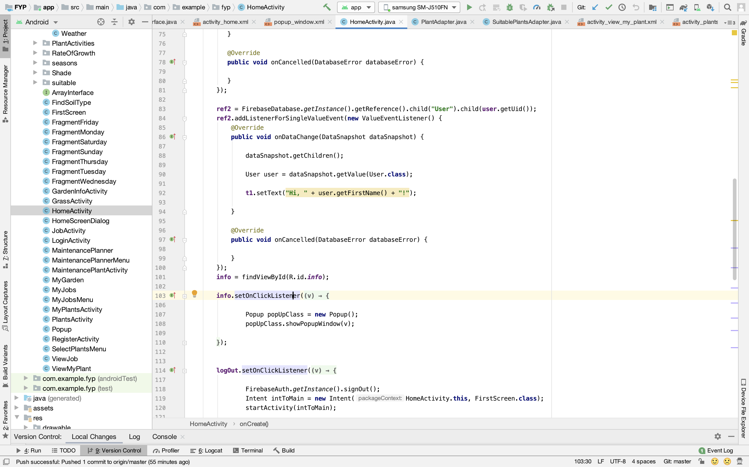

**New User Popup**

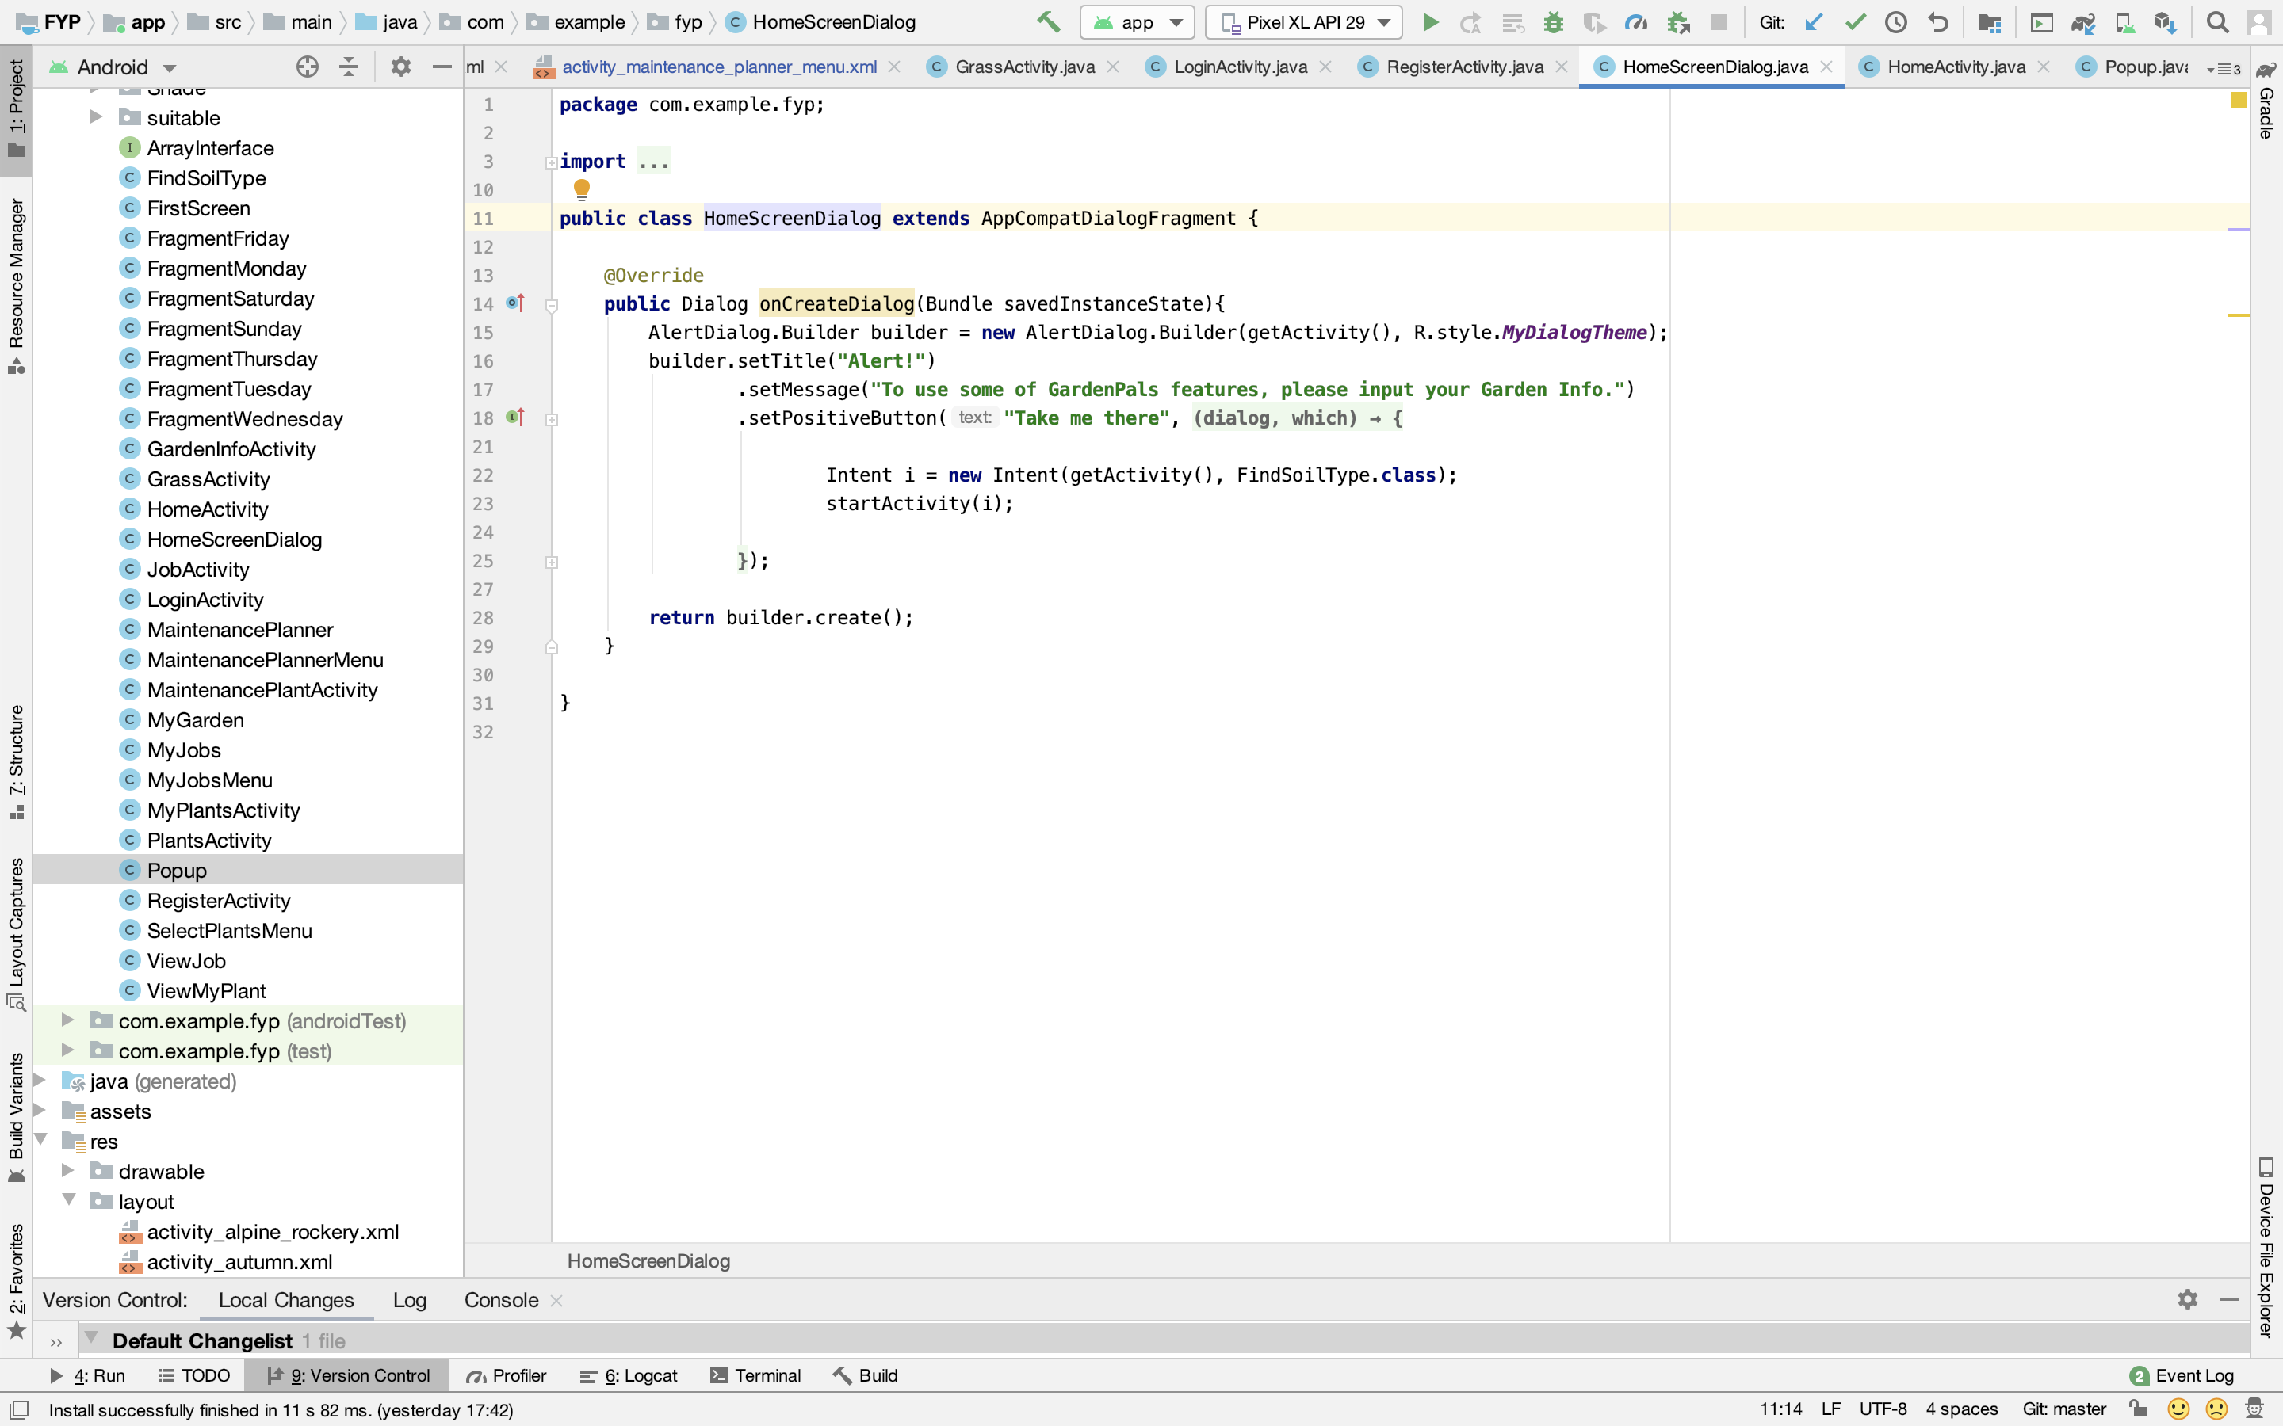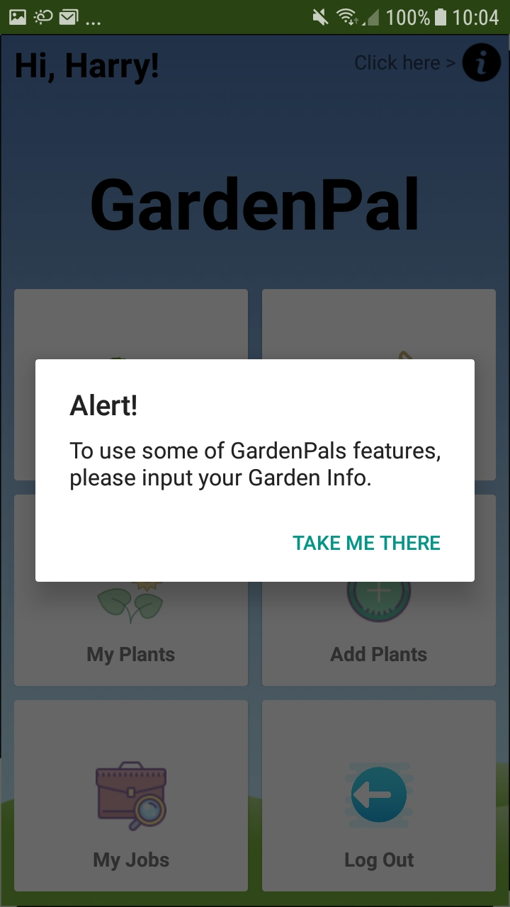After a user completes registration they are forwarded to the home screen and this pop up message appears, informing the user they must fill in their garden details. It is vital that the user does this as the app will be unable to give recommendations on plants and give accurate information about cutting grass. When the user clicks ‘Take me there’ they are forwarded to a screen to fill in their garden details.

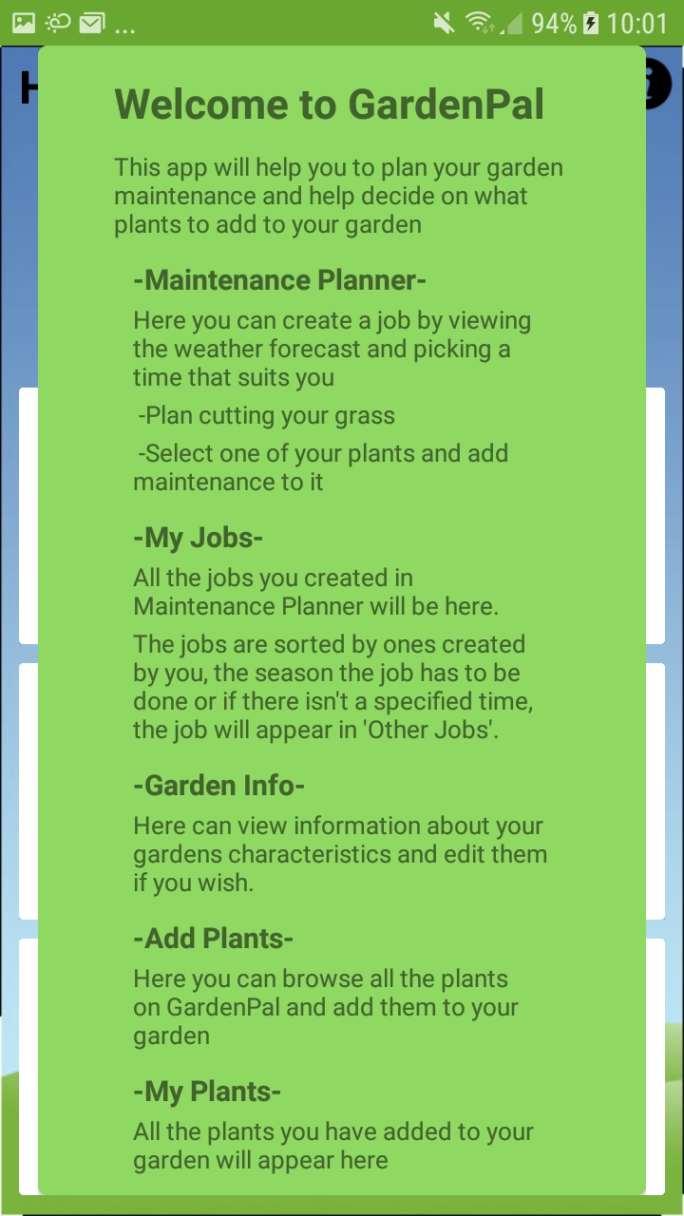**Menu Popup**

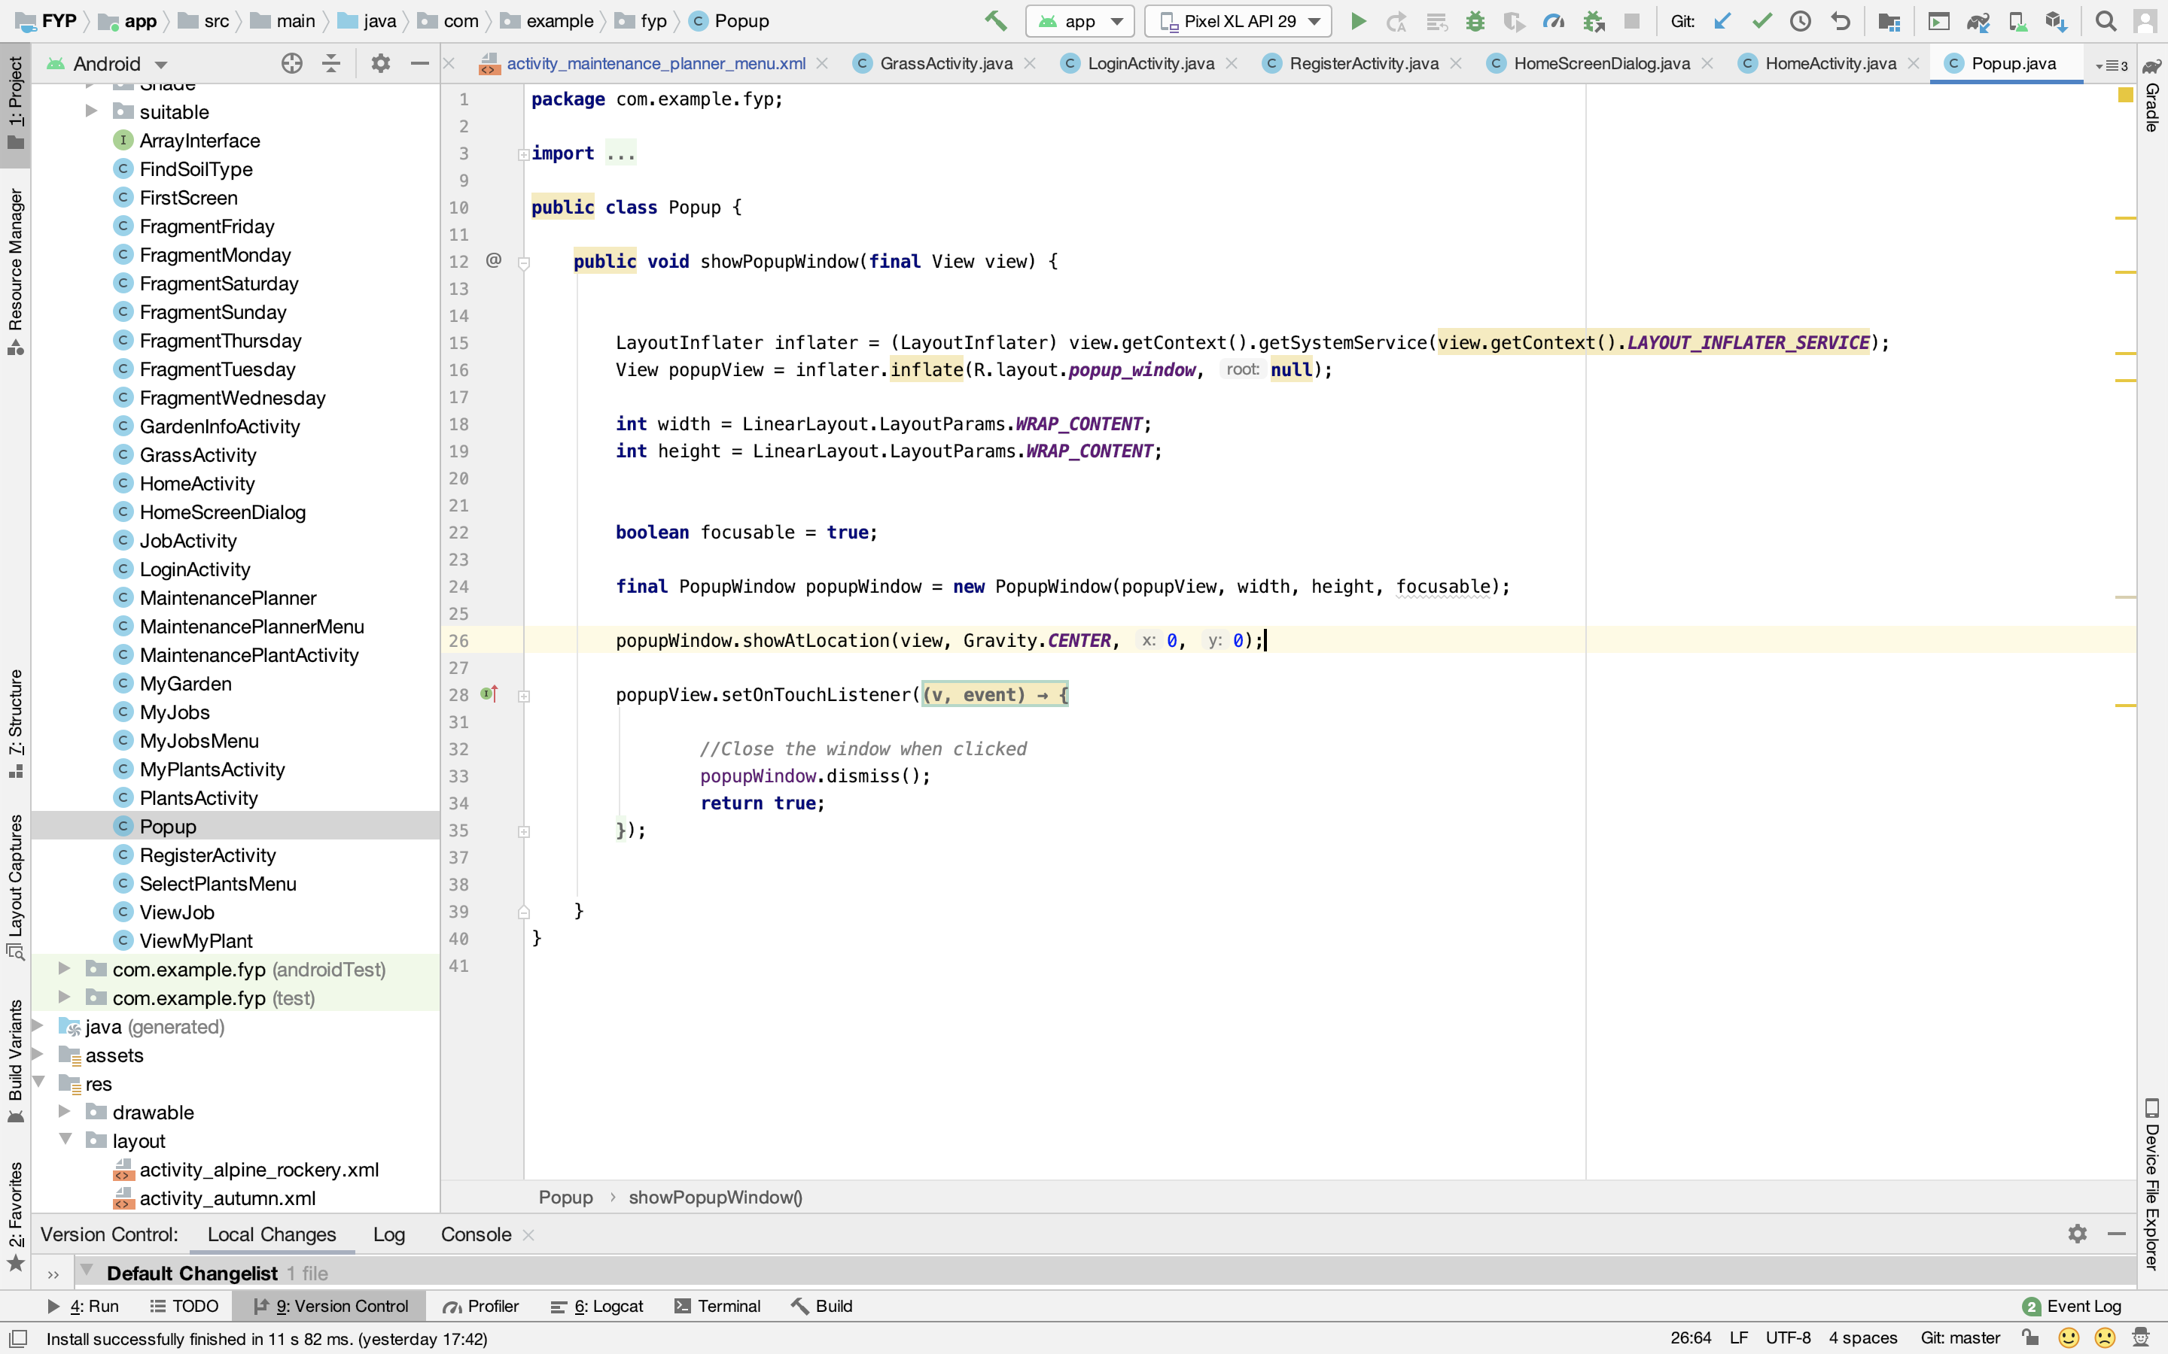When the user clicks on the info button at the top right of the home screen they are shown this pop up screen. This screen tells the user what each of the menu items does. User can keep referring to this pop up if they are ever unsure of what some of the features of the app does. There is text beside the icon ‘click here>’ to encourage new users to learn about GardenPal and what it does.

**Garden Info**

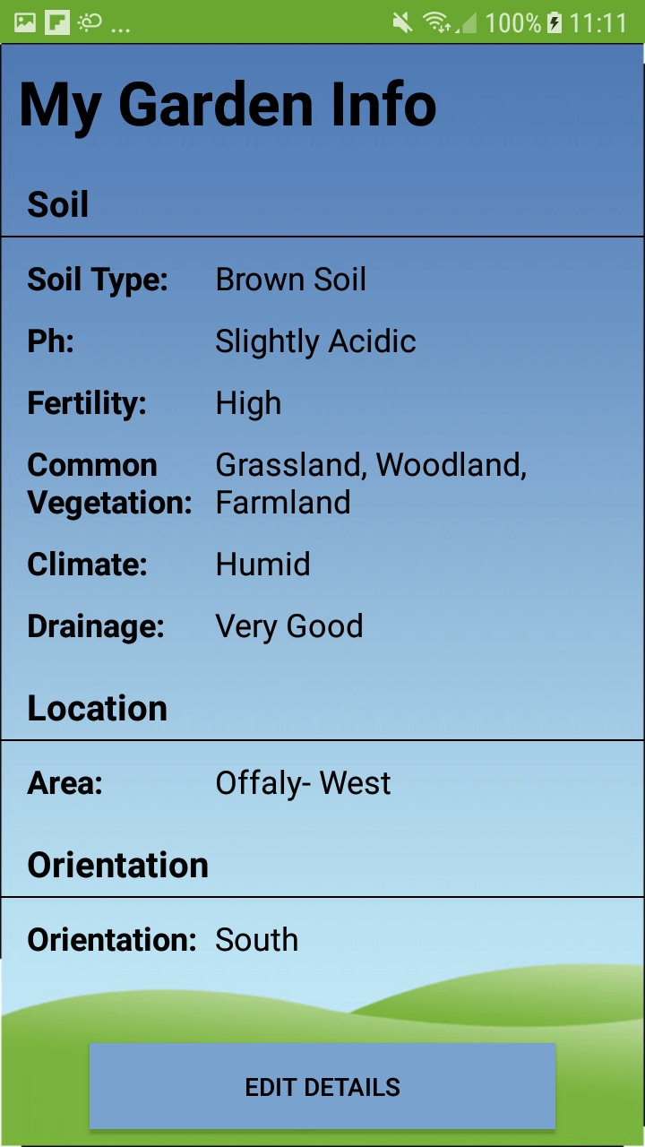

In the Garden Info screen the important details of the user’s garden are displayed, including soil type, area and the orientation of their garden. This information is vital in all other parts of the app. If the user wants to edit these details they can tap the ‘edit details button’.

The garden information is stored in firebase, when the user opens this screen, the app sends a query to the database to get the information for the specific user.

**Edit Garden Info**

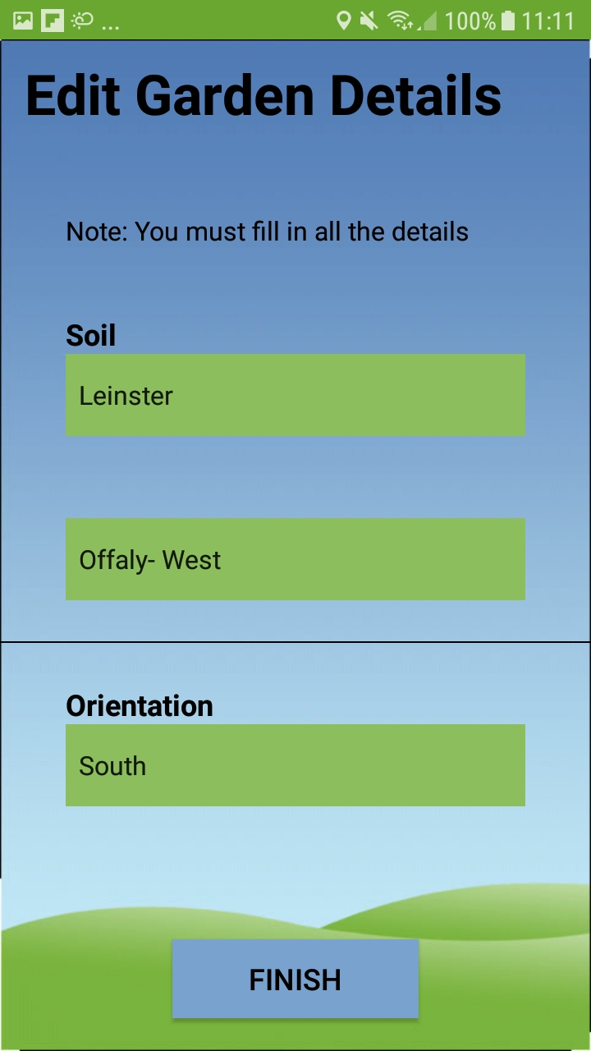

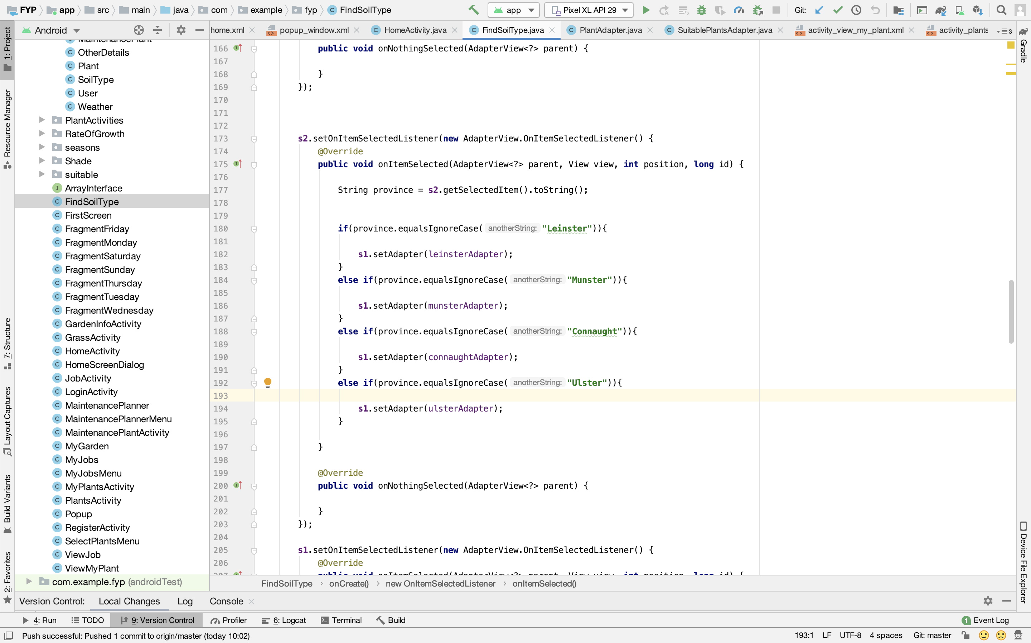

On this screen, the user inputs in their location by selecting what province they are in and then what area they are living in. The second dropdown list populates differently depending on what province the user selects. The user also has to input the orientation of their garden as the orientation is a key factor in how fast grass grows.

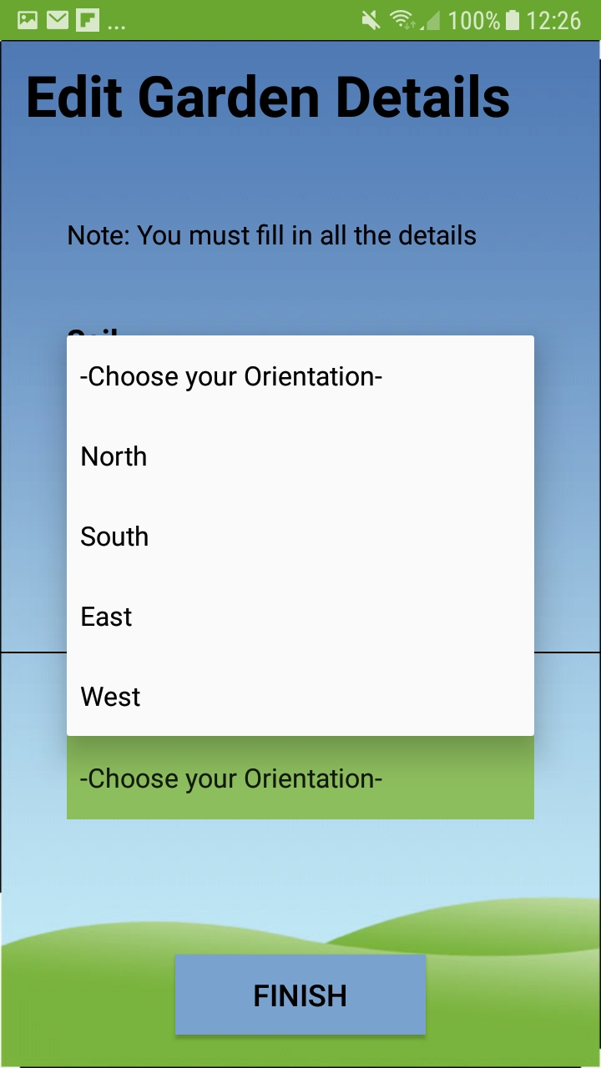

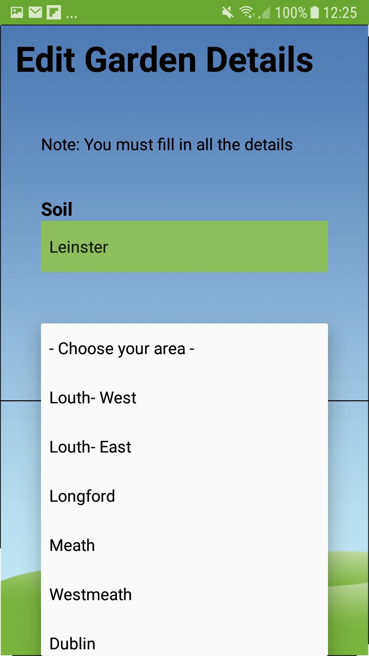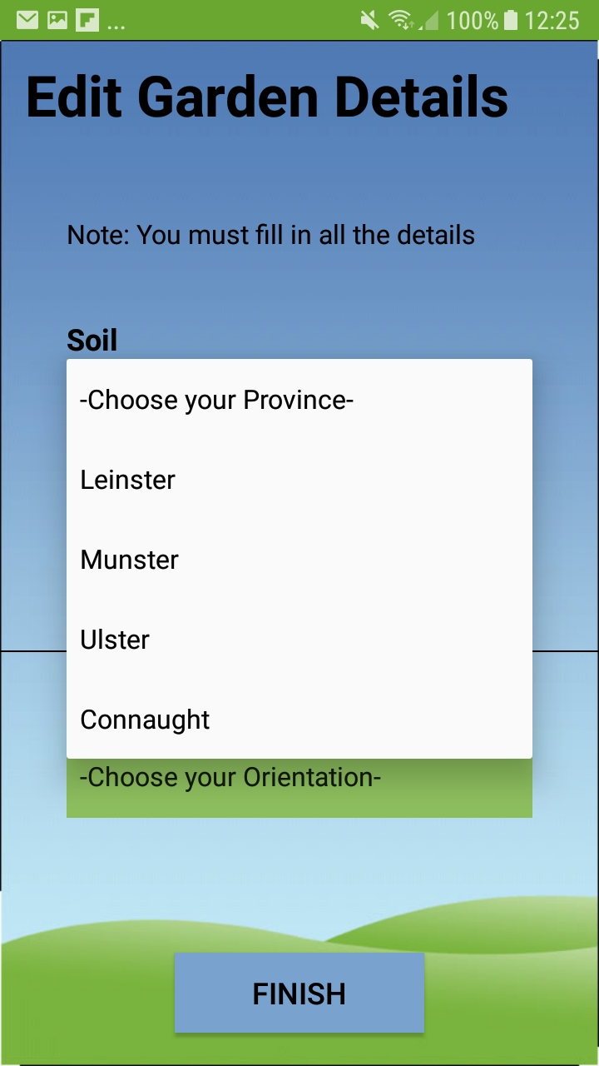

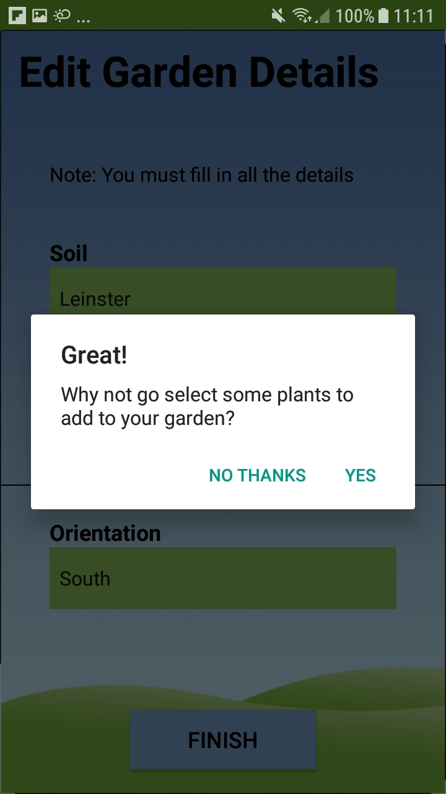When the user finishes inputting their garden details and taps the ‘finish’ button they are presented with another pop up that encourages them to go add some plants to their garden. This was implemented with new users in mind as it helps to guide them through the app and expose them to another feature of the app.

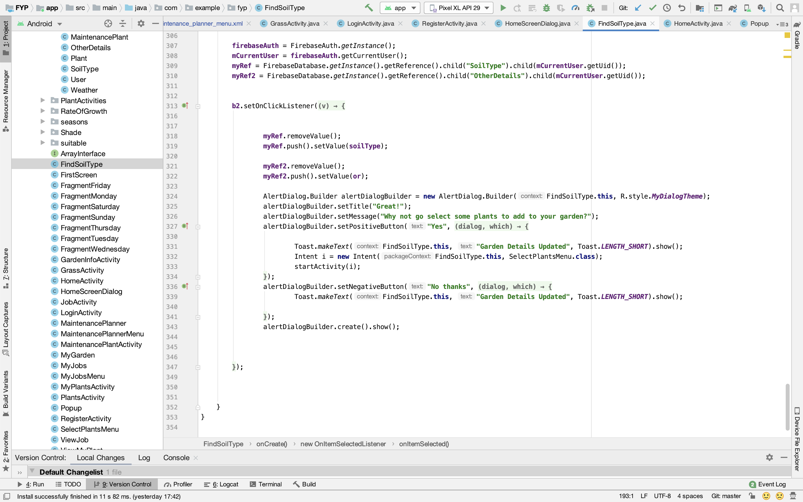

**Add Plants**

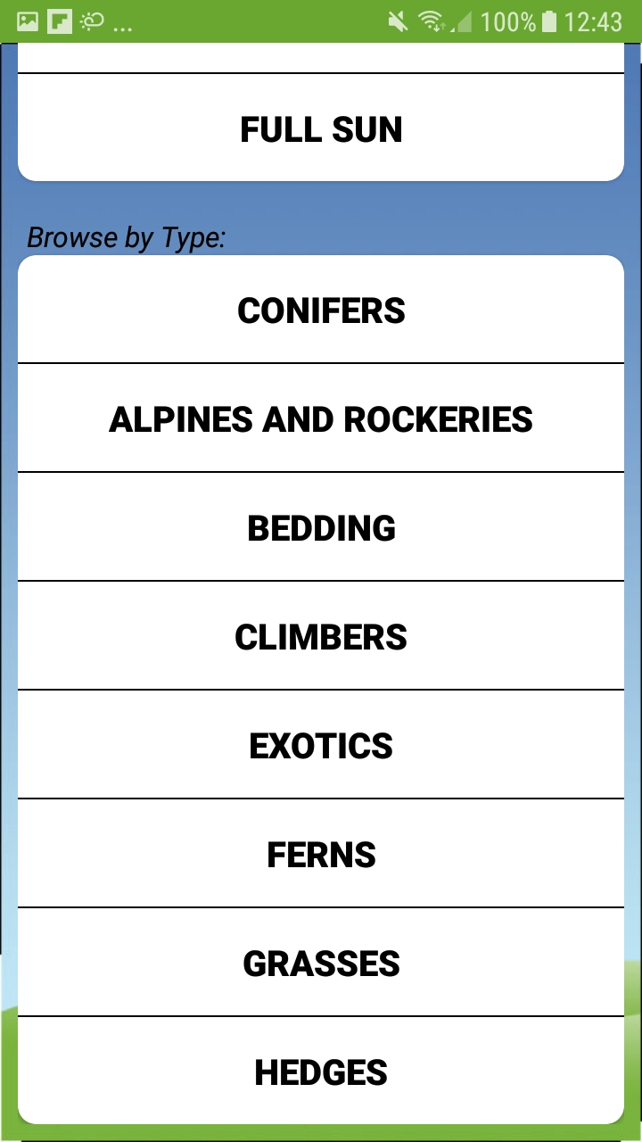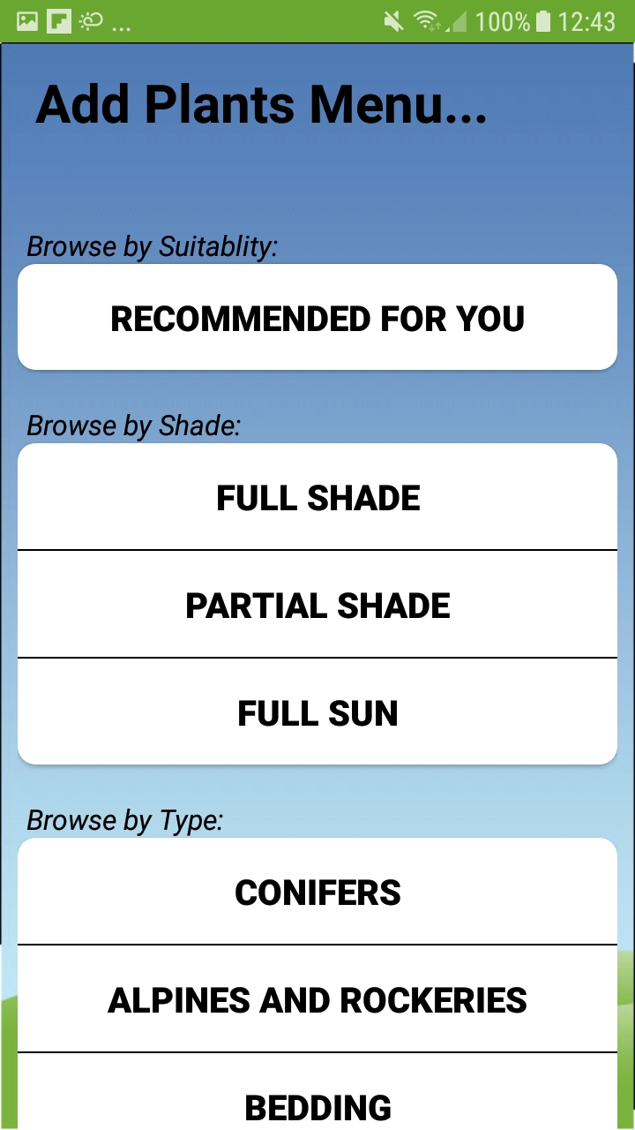

When the user taps on the ‘Add Plants’ option they are brought to the Add Plants Menu screen. Here the user can browse all the plants on GardenPal.

They can browse plants that are suitable for their garden, browse plants by how much sun they require or just browse plants by type.

**Recommended Plants Screen**

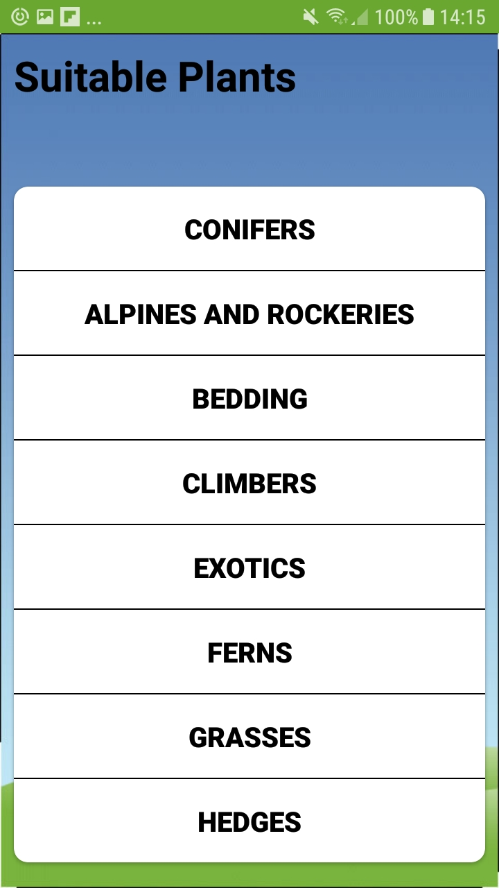

When the user clicks on the ‘Recommended For you’ menu option they are brought to this menu screen. They can click into any of these menu options and it will display only plants that are suitable for the user’s garden.

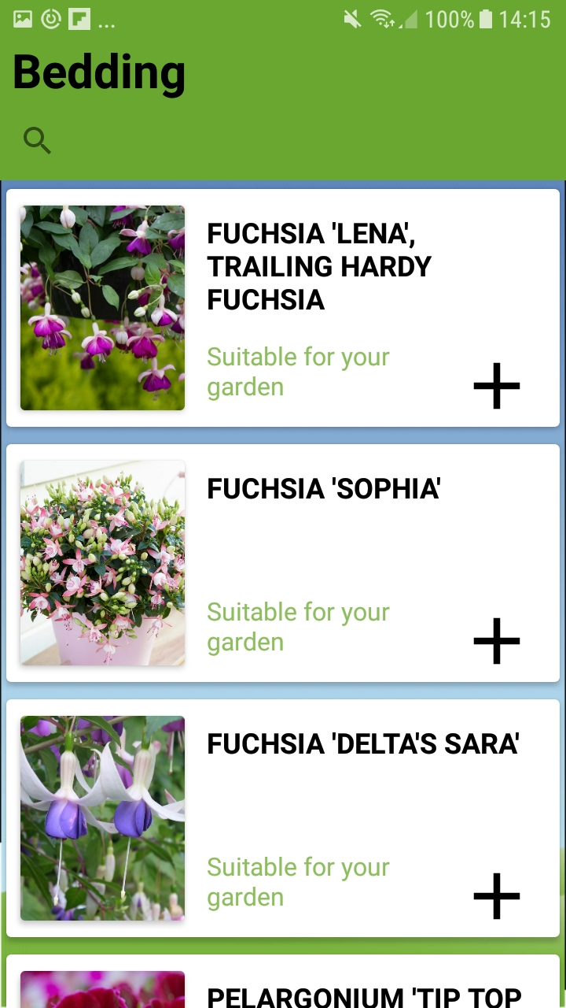

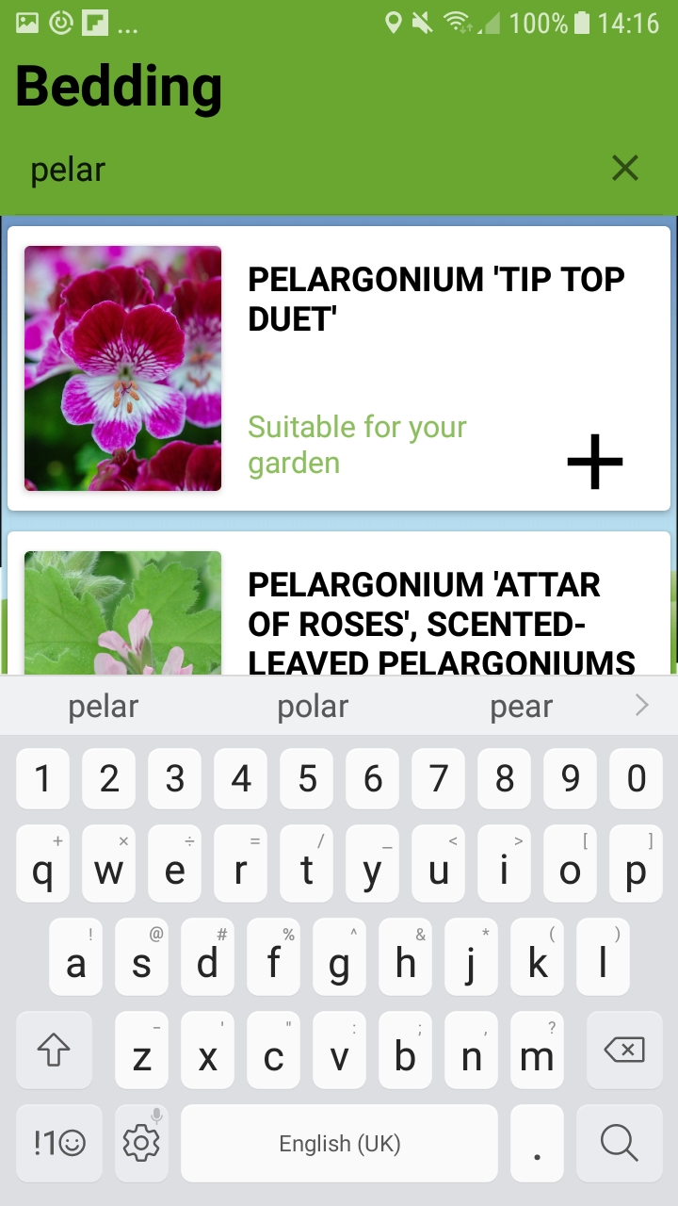The user can scroll through all the plants and tap the ‘+’ button on the plant they like and it will be added to ‘My Plants’. They can also click into a plant to view more information on it. If the user has a particular plant in mind they can tap the magnifying glass and search for the plant they are looking for.

To filter out the plants that are not suitable, this class has an adapter class which populates the recyclerview. Within the adapter class is an **algorithm** that analyses the characteristics of the plant and the characteristics users garden. The adapter then only adds the plants that match the user’s gardens characteristics to the recyclerview.

The algorithm is explained in more detail on the next page.

**Algorithm for selecting Recommended Plants**

This algorithm is used for decided if a plant is suitable or not for the user’s garden.

It is called in the onBindViewHolder method in the **SuitablePlantsAdapter.java** class, when the adapter is populating the recyclerview which shows all suitable plants to the user.

Firstly, a query is sent to the database to get the users soil type.

reference = FirebaseDatabase.*getInstance*().getReference().child(**"SoilType"**).child(user.getUid());

Then for each plant in question, its characteristics are compared to the characteristics of the user’s soil type. Plants with certain characteristics that are **not** suitable are removed from the list of plants that will be displayed to the user. Plants that are partially suitable are also removed as they are not optimal for the garden of the user in question.

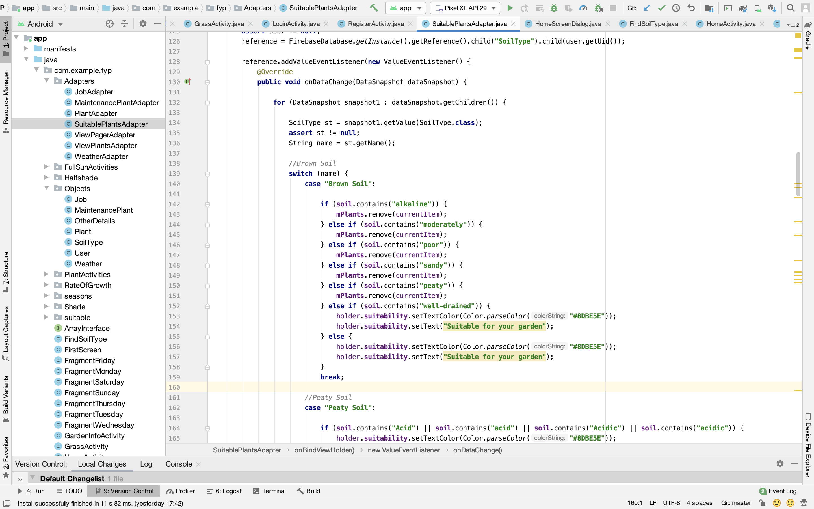

**Full Sun, Partial Sun and Full Shade Screens**

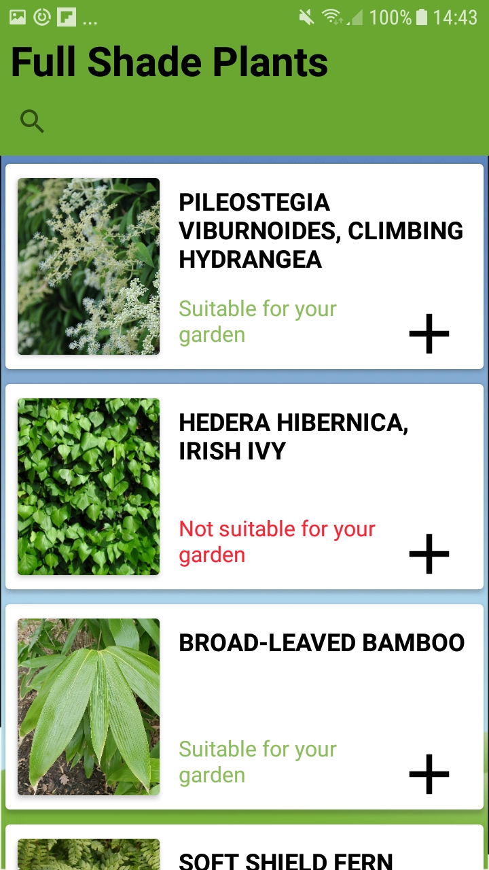

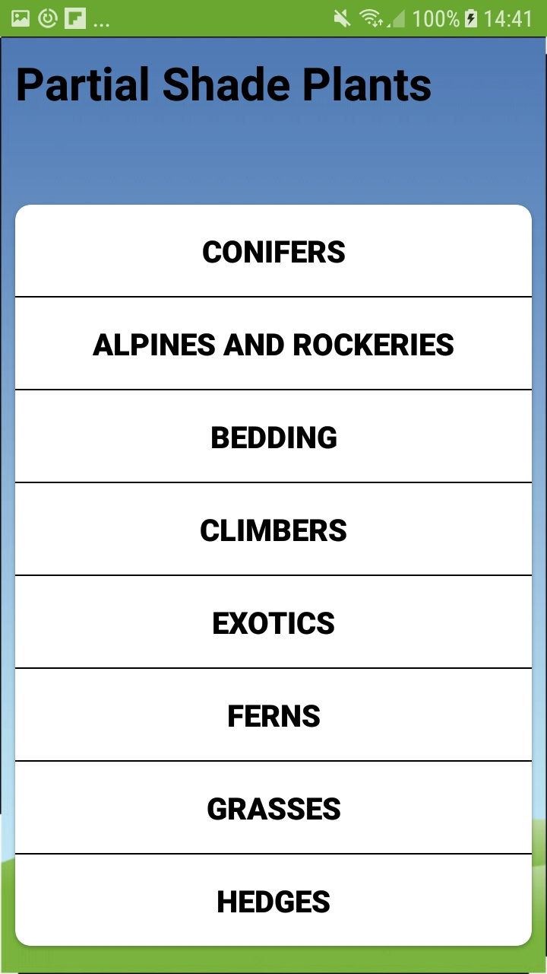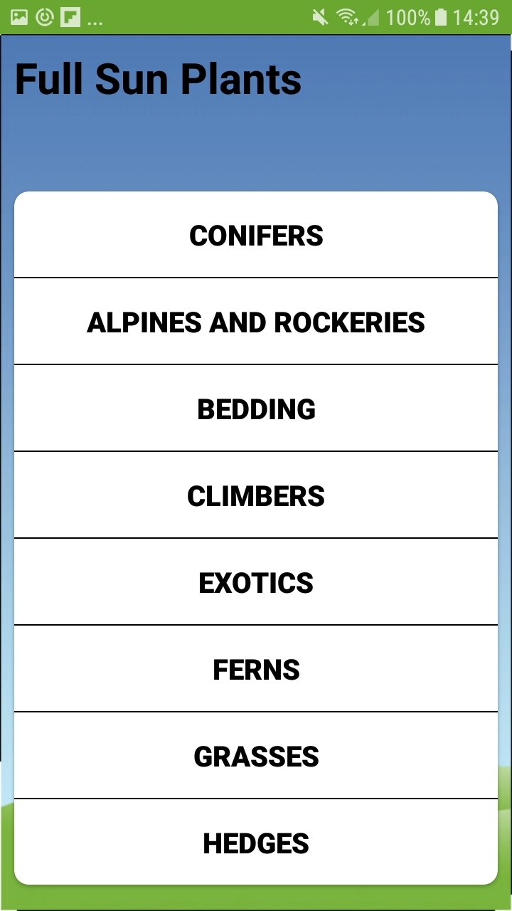

If the user wants to browse plants by how much sun they need they have the options of…

**Full Sun:** Plants that like to be in direct sunlight all the time.

**Partial Shade:** Plants that like some shading but not fully shaded.

**Full Shade:** Plants that like to be shaded all of the time.

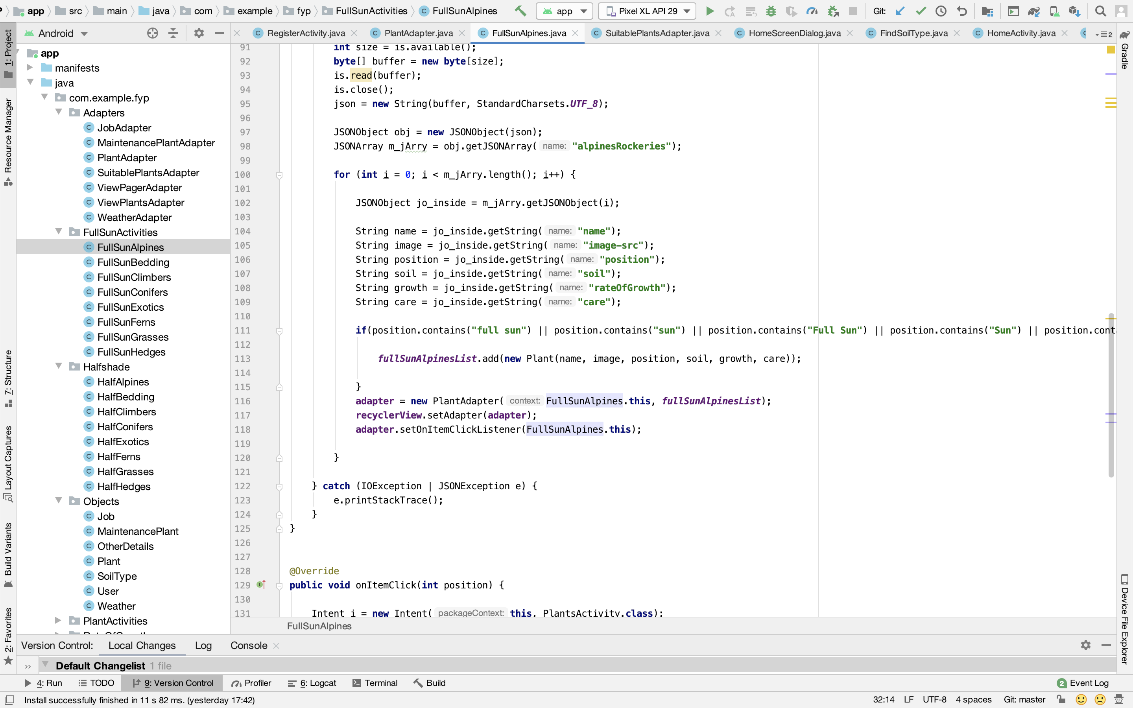

The plant data is stored in json files within the app. There files are parsed using a json parser method. There are ‘if’ statements within the method used for parsing the plant objects are added different Arraylists, depending on how much shade they need.

**Browse by Type Screen**

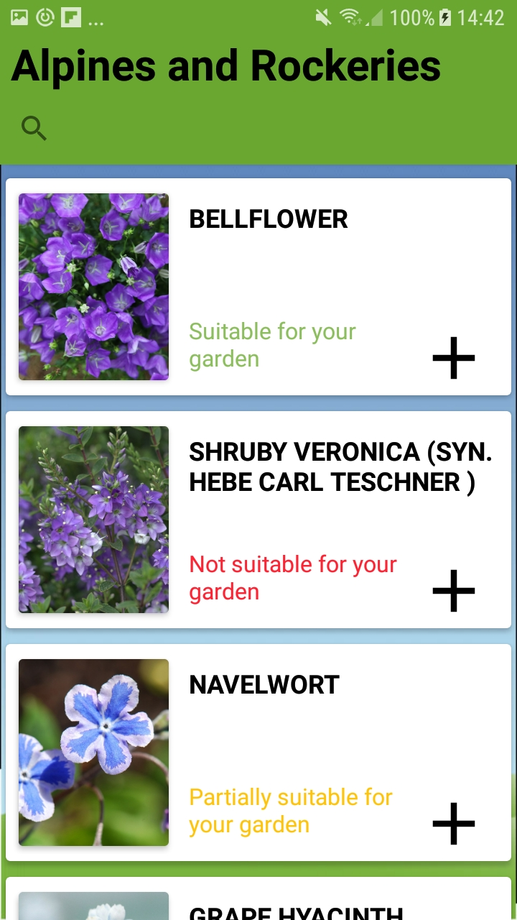

If a user just wants to just browse by the type of plant, they can. When they click one of the menu options they are presented with a list of plants for that type e.g. Alpines and Rockeries.

For each plant, GardenPal analyses the plant to see if it will be suitable for the user’s garden or not. It is using an algorithm that is analysing the users garden characteristics and the characteristics of the plant to give a recommendation.

The 3 recommendations are as follows…

**Suitable:** The plant is perfect for the user’s garden.

**Partially Suitable:** Some of the plants characteristics match the characteristic of the user’s garden but not all of them.

**Not Suitable:** None of the characteristics of the plant match the characteristics of the user’s garden.

The user can still add any plant they want to ‘My Plants’, these recommendations are only recommendations, the user still has full control of what they add to their garden.

**Algorithm for the suitability of a plant**

This algorithm is similar to the one for selecting suitable plants with some small differences.

It is called in the onBindViewHolder method in the **PlantAdapter.java** class, when the adapter is populating the recyclerview which shows all suitable plants to the user.

A query is sent to the database to get the soil type of the user’s garden.

reference = FirebaseDatabase.*getInstance*().getReference().child(**"SoilType"**).child(user.getUid());

Each plant is then compared to the characteristics of the user’s soil type and based on how suitable the plant in question is a textfield or each plant is populated with GardenPals recommendation.



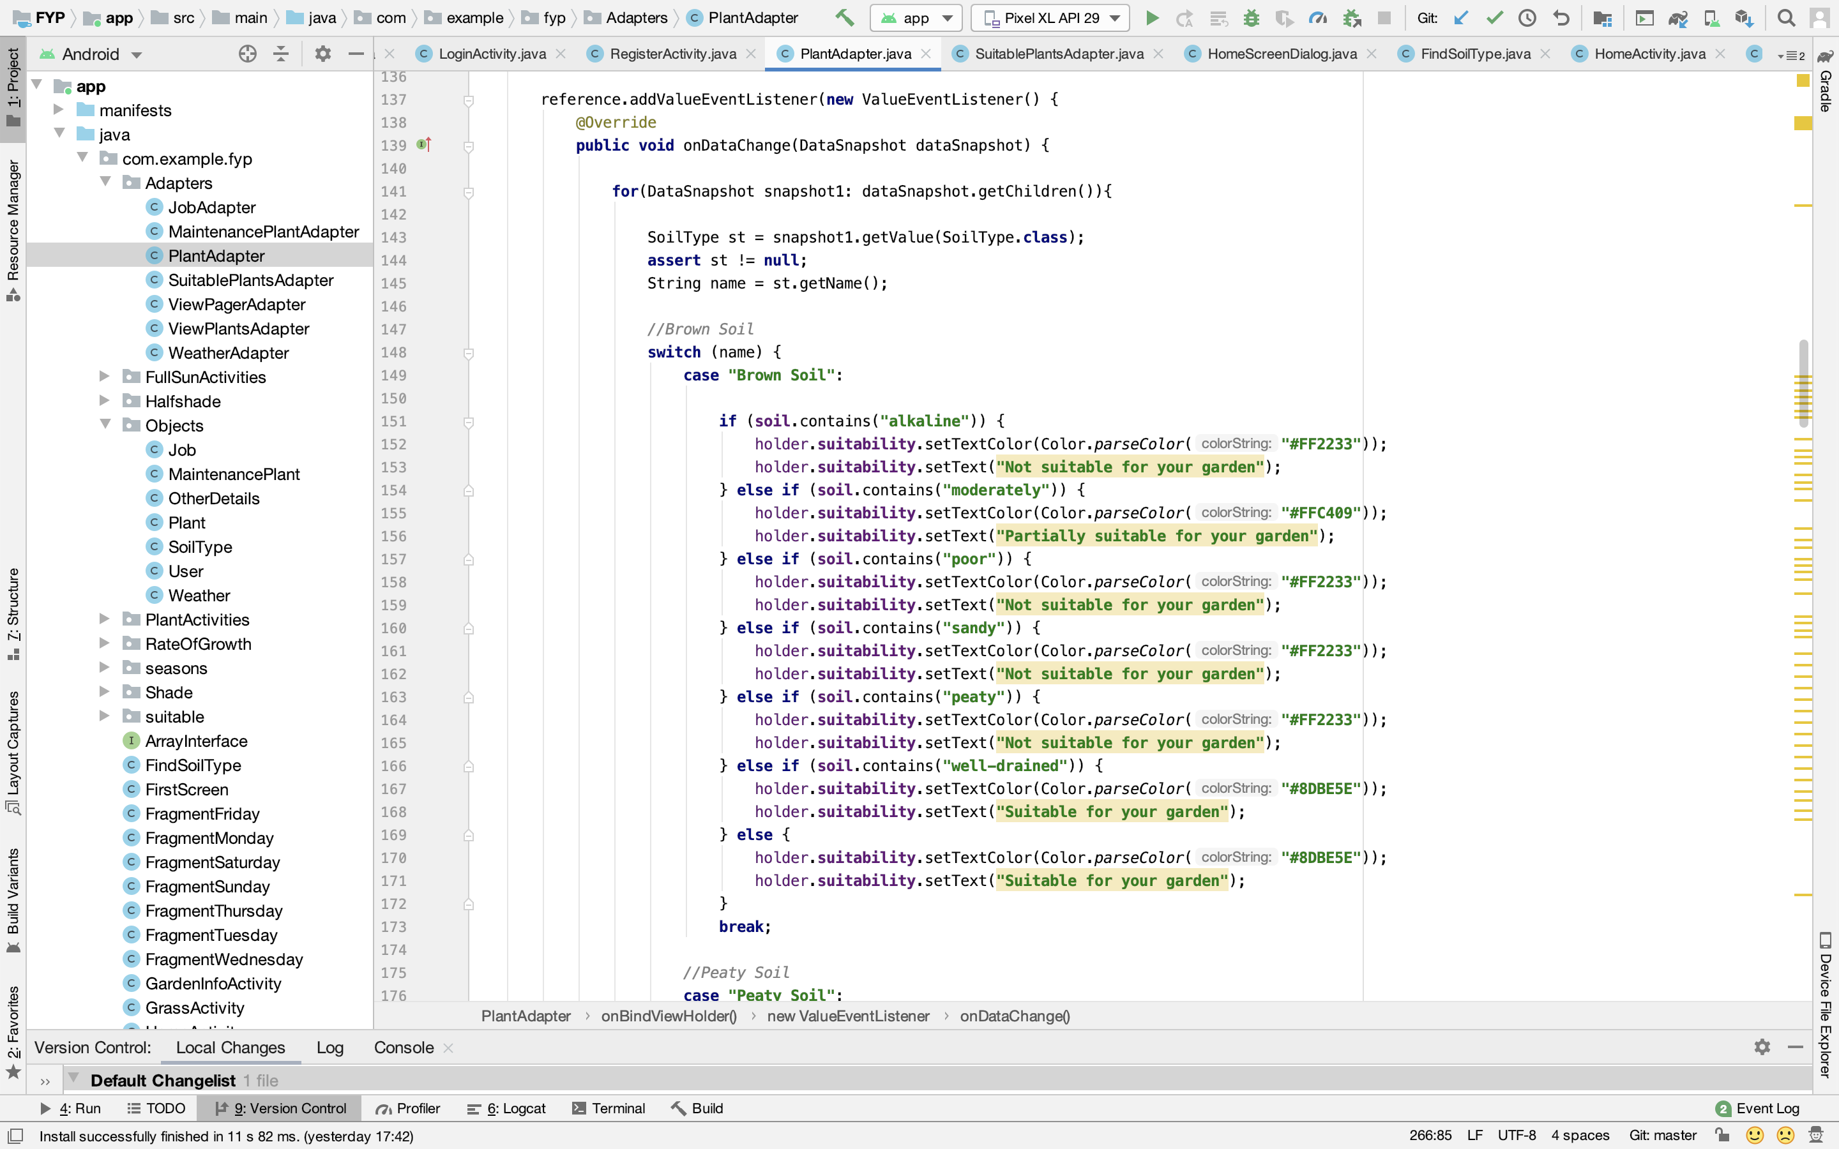

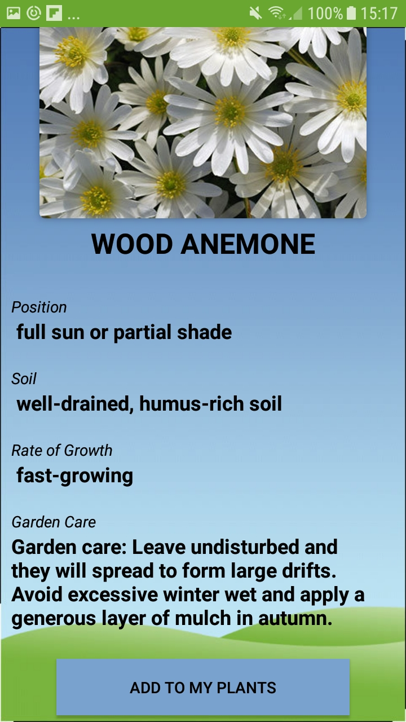**View Plant Screen**

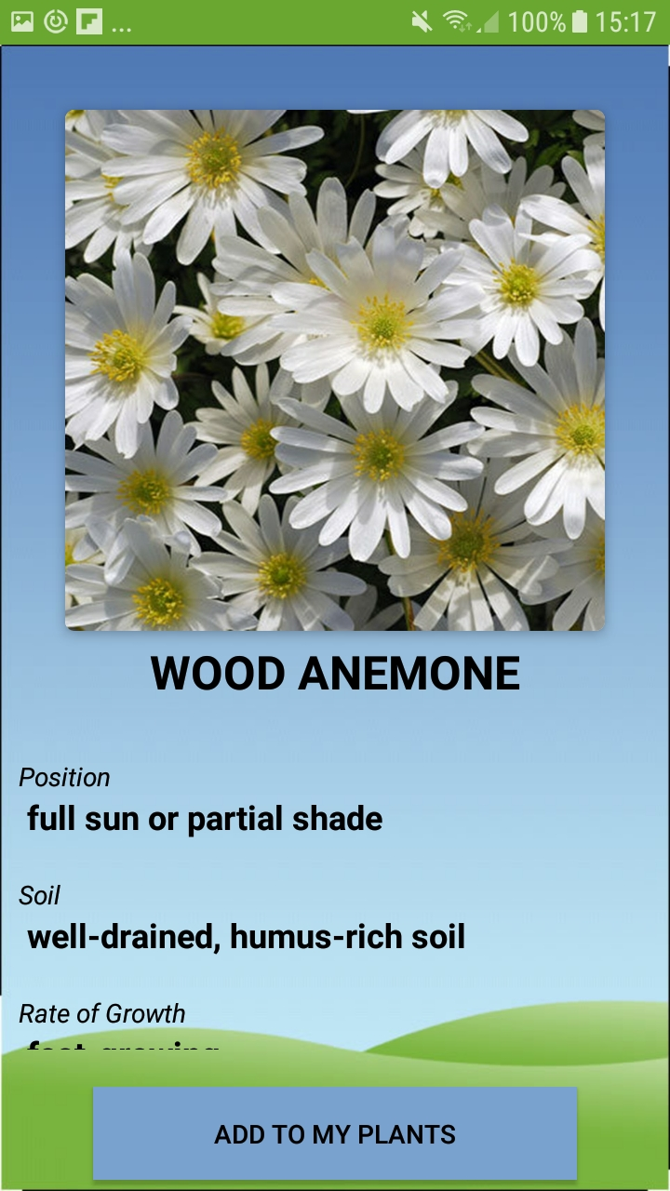

When the user clicks on a plant, they are brought to this screen to view more information on the plant. Here they can see where to place the plant, the type of soil it needs, how fast it grows and most importantly, how to take care of the plant.

The can also click the ‘Add to My Plants’ and it will add the plant to the users list of plants.

**My Plants Screen**

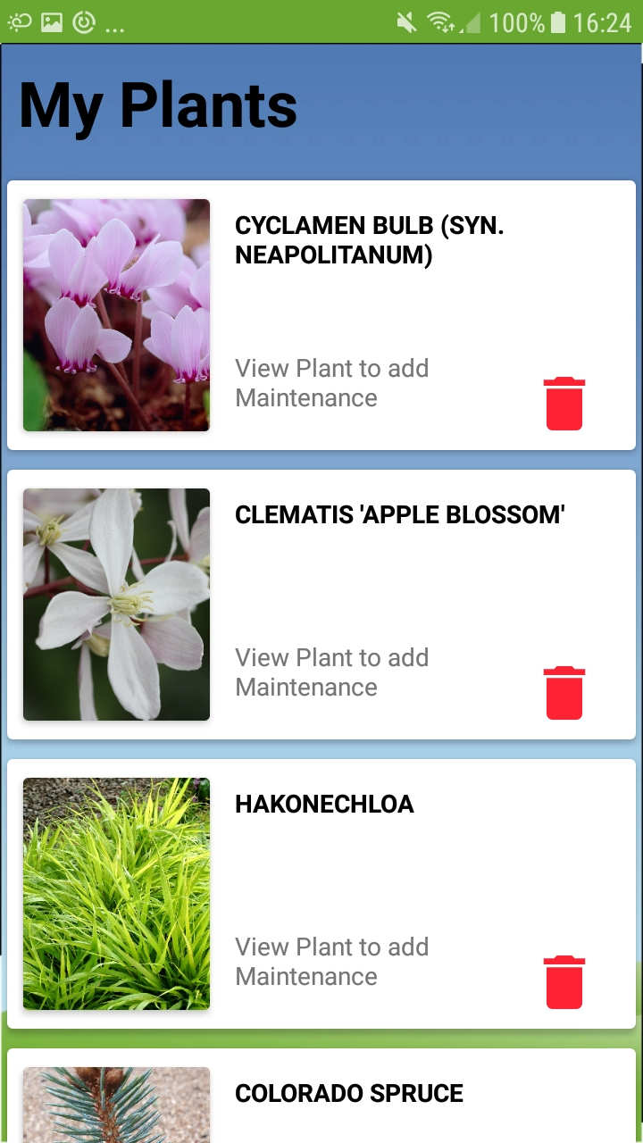

My Plants contains all the plants the user has added while browsing plants. They can scroll through all their plants and remove them from the list by clicking the red bin button, this will permanently the delete the plant, but if the user decides they want this plant later they can go back to ‘Add Plants’ and add it back in.

The user can also click on one of their plants to view more information on it.

**View My Plant Screen**

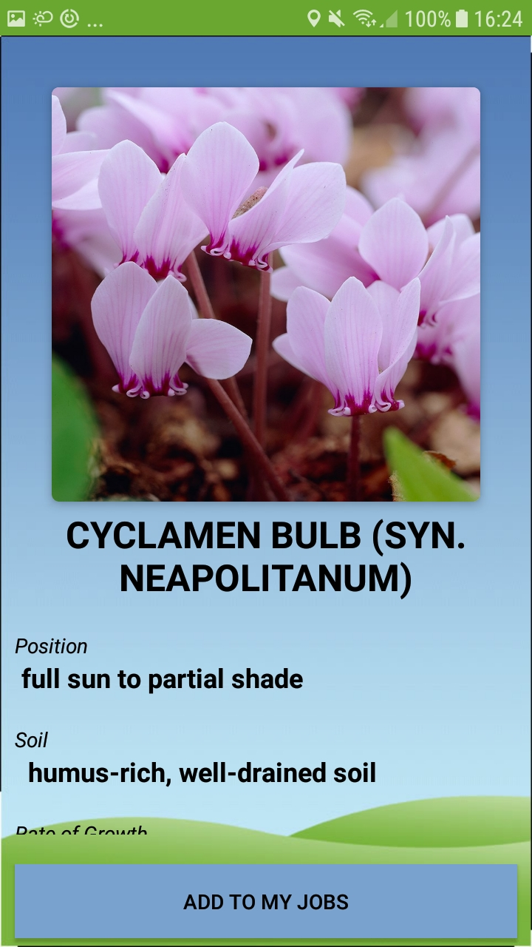

When the user clicks on one of their plants they are brought to this screen. It is identical to the one the user sees when they click a plant while browsing in ‘Add Plants’ apart from the button at the bottom.

The ‘Add to My Jobs’ button analyses the Garden Care section at the bottom of the View Plant Screen. It uses an algorithm to find a time that the plant needs maintenance and adds a job to the appropriate section of ‘My Jobs’.

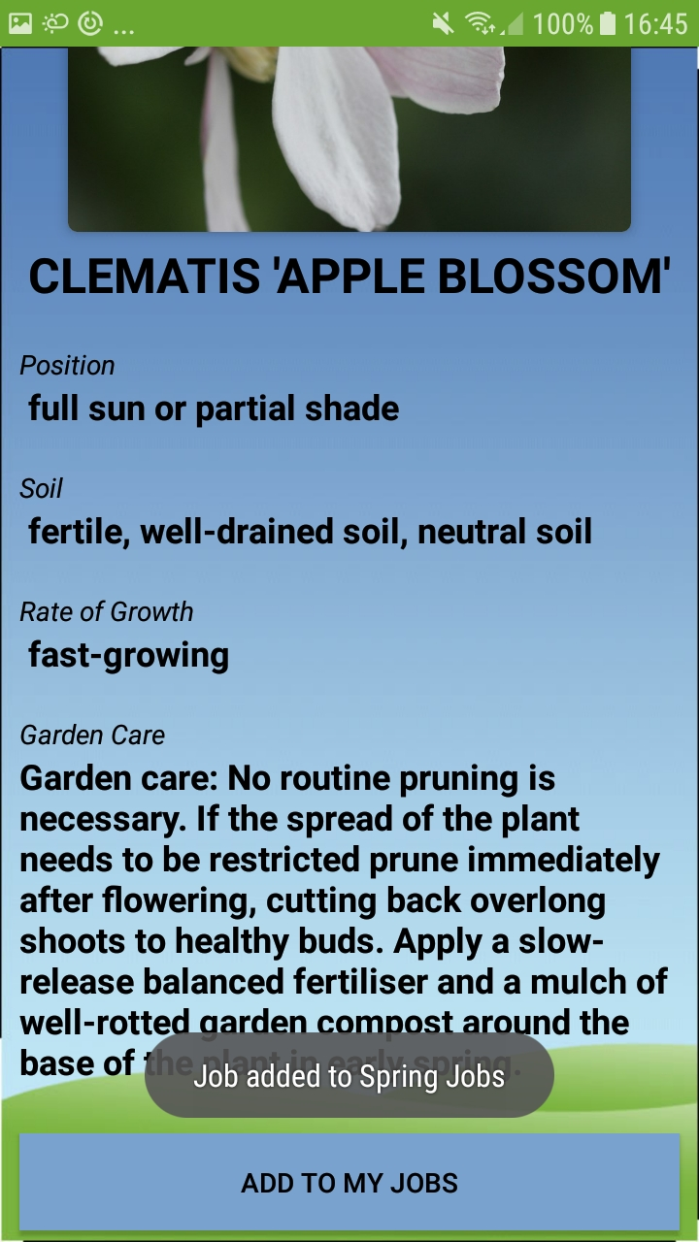When the user clicks the ‘Add to my Jobs’ button its displays a popup message to the user telling them where in ‘My Jobs’ the job has been added.

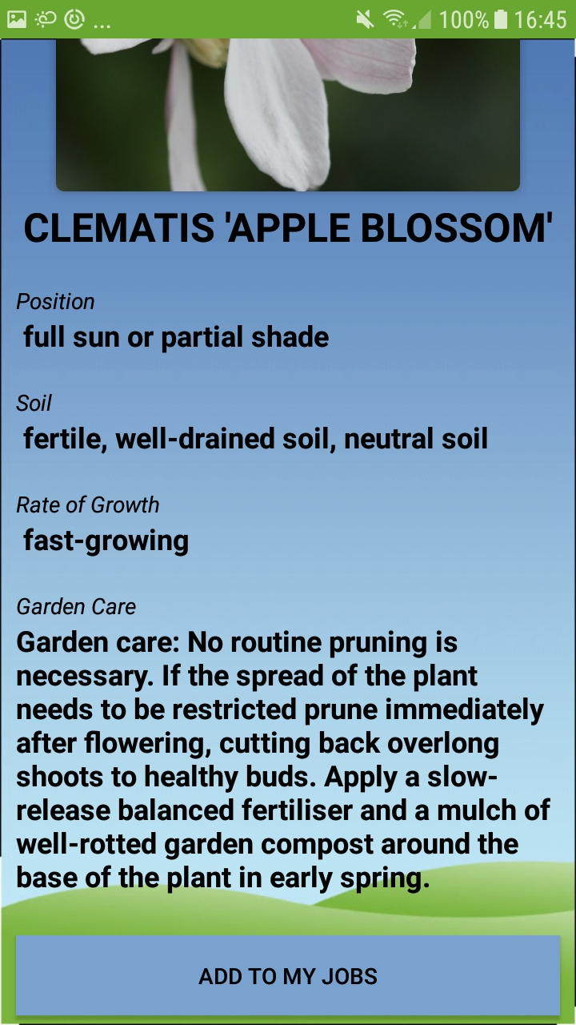

**Deciding what season a plant requires maintenance**

When the user clicks on ‘Add to my Jobs’ GardenPal examines the Garden Care section of the plant.

It is looking for a season of the year in which the plant requires maintenance. If, for example, it finds that a plant requires maintenance in Spring, like the plant above, then that plant will be pushed to a table in the database called ‘SpringJobs’.

If there is no specified time for maintenance then the job is added to the table ‘OtherJobs’.

**autumnRef** = FirebaseDatabase.*getInstance*().getReference().child(**"AutumnJobs"**).child(**mCurrentUser**.getUid());  
**springRef** = FirebaseDatabase.*getInstance*().getReference().child(**"SpringJobs"**).child(**mCurrentUser**.getUid());  
**winterRef** = FirebaseDatabase.*getInstance*().getReference().child(**"WinterJobs"**).child(**mCurrentUser**.getUid());  
**summerRef** = FirebaseDatabase.*getInstance*().getReference().child(**"SummerJobs"**).child(**mCurrentUser**.getUid());  
**otherRef** = FirebaseDatabase.*getInstance*().getReference().child(**"OtherJobs"**).child(**mCurrentUser**.getUid());

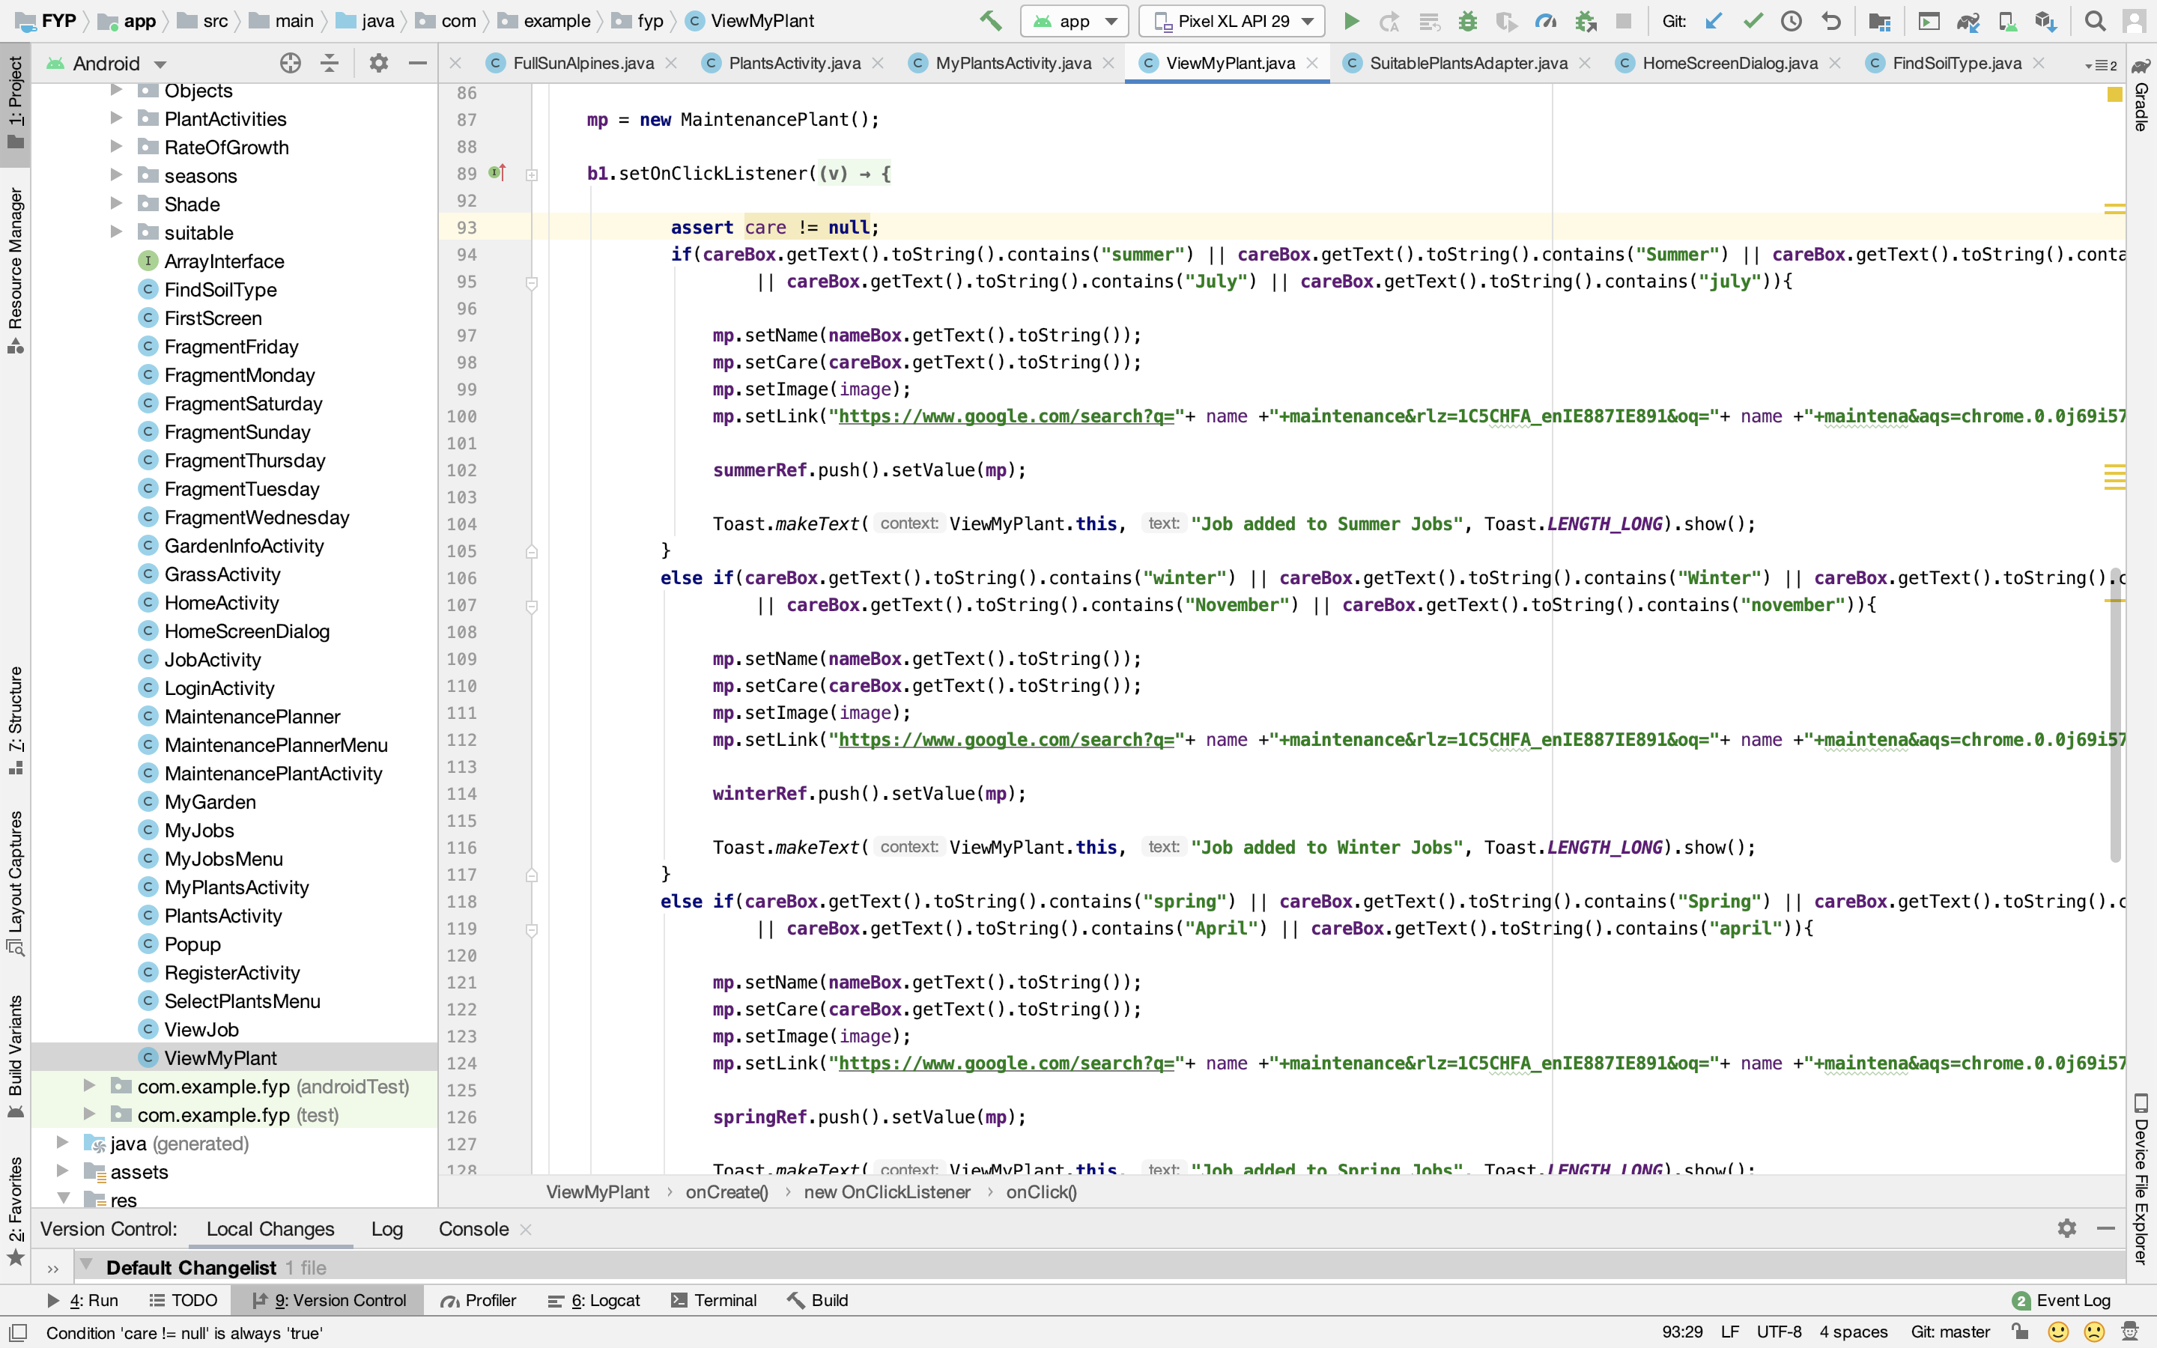

**Maintenance Planner Menu Screen**

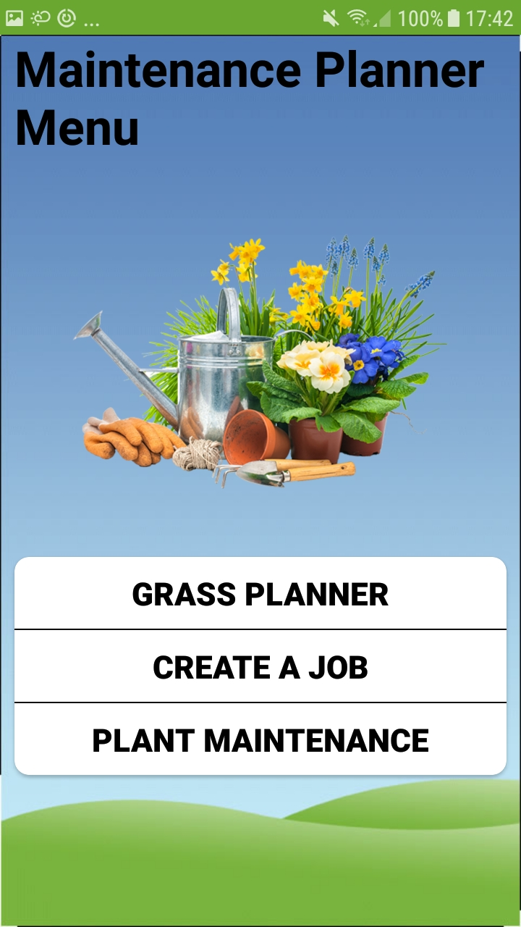

This is the maintenance planner menu. Here the user can plan all their garden maintenance.

**Grass Planner:** The user can view information about when to start and stop cutting grass in the year and how often they should cut it.

**Create a Job:** Here the user can view the weather forecast and select a day and time that suits them to create a job.

**Plant Maintenance:** By clicking this menu option the user is forwarded to ‘My Plants’ to select a plant and add it to their jobs like before.

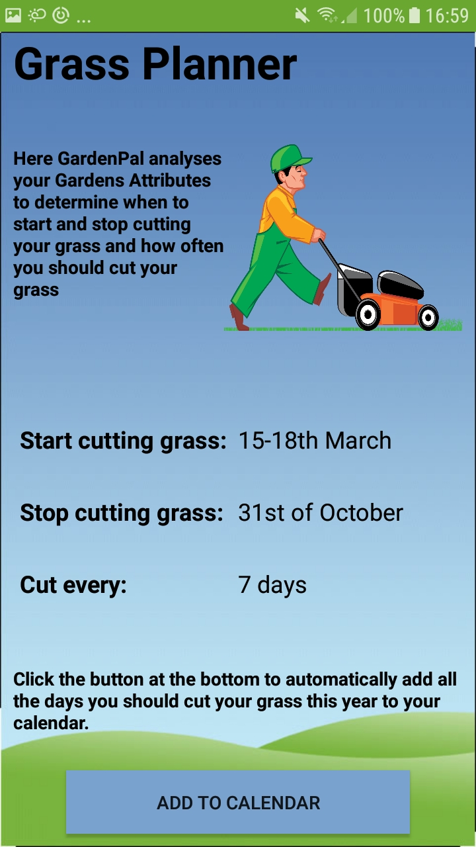**Grass Planner Screen**

On this screen GardenPal analyses the users soil type and the orientation of the user’s garden to tell them when to start cutting grass in the year and when to stop. It also tells them how regularly they should cut it. There is a button at the bottom the screen and if the user clicks it will open the calendar to allow the user to add all the cuts in the season to the calendar on their phone.

To get the ‘Start cutting grass’ time the app sends a query to the database looking for the user’s soil type and sets the textfield with the date.

The stop time is the same regardless of soil type and orientation.

For this information, I consulted my father who a professional landscaper as I wanted to ensure the user receives accurate information.

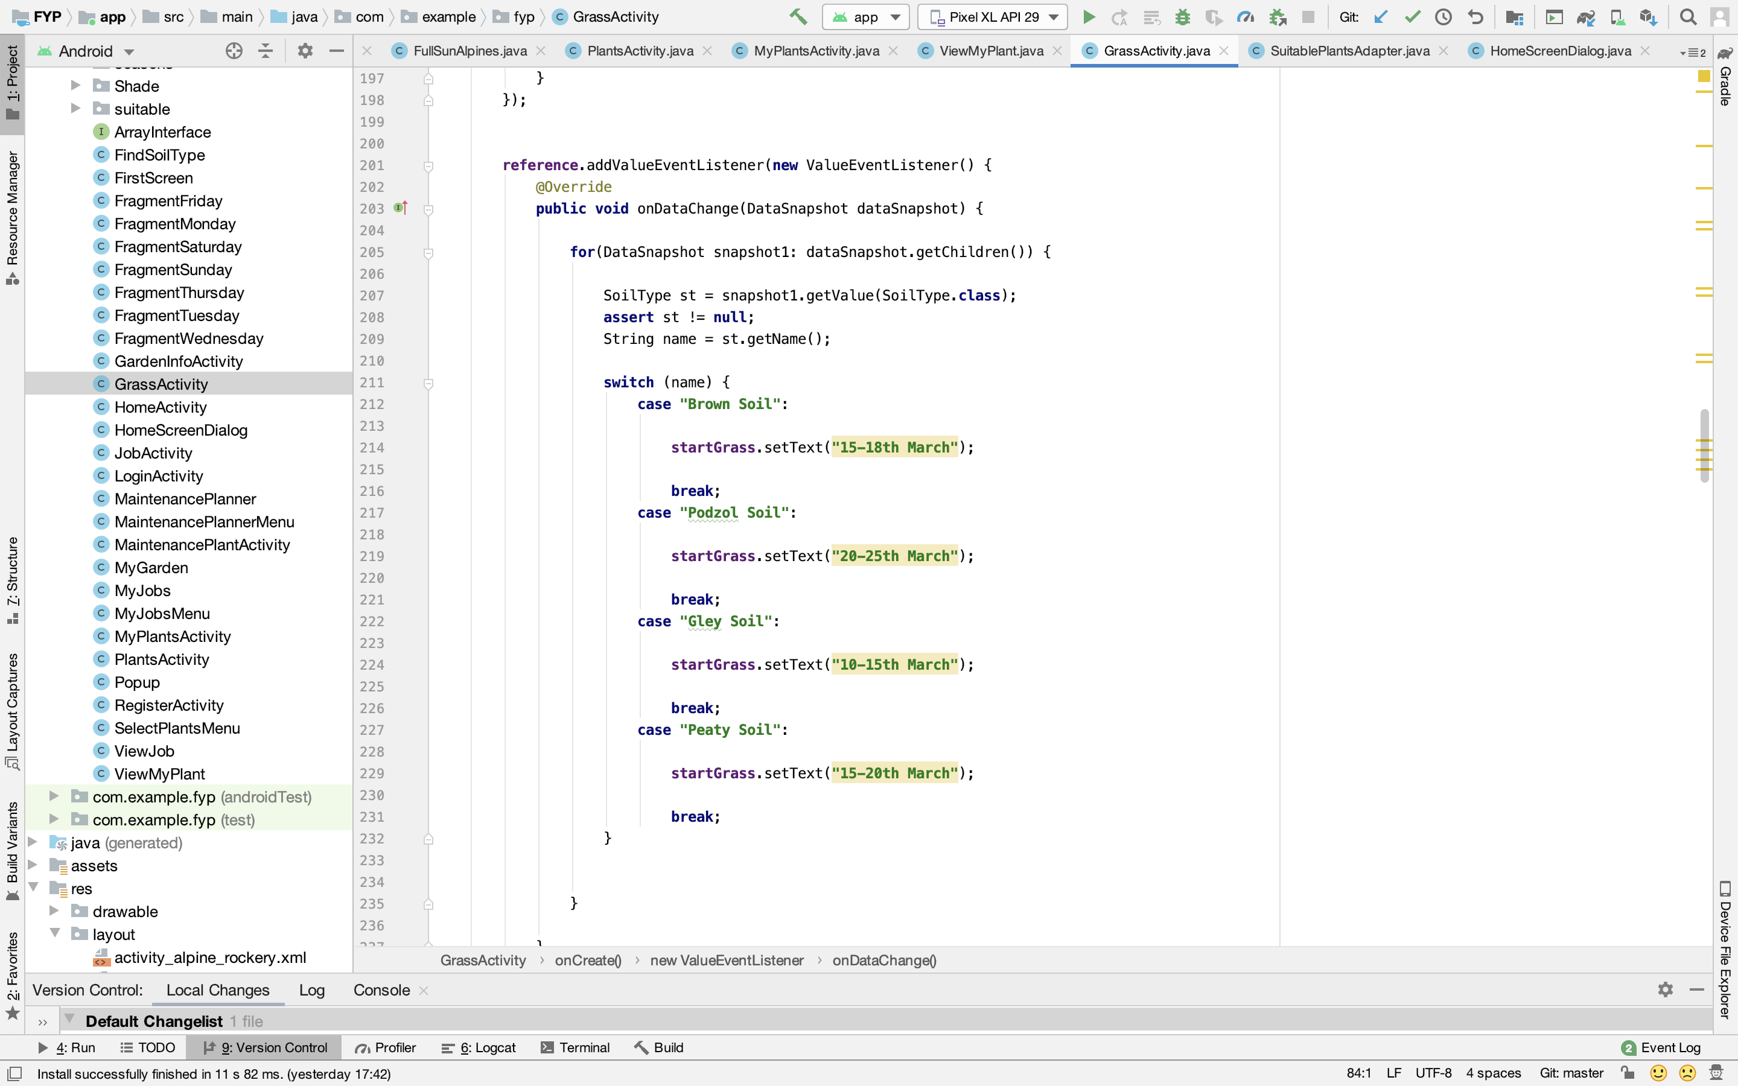

**Algorithm for how often grass should be cut**

In the **GrassActivity.java** class a query is sent to the database to the get the users soil type and the orientation of the user’s garden.

**reference** = FirebaseDatabase.*getInstance*().getReference().child(**"SoilType"**).child(**user**.getUid());  
**reference2** = FirebaseDatabase.*getInstance*().getReference().child(**"OtherDetails"**).child(**user**.getUid());

Then the algorithm matches each soil type to each type of orientation to tell the user how often they should cut their grass.

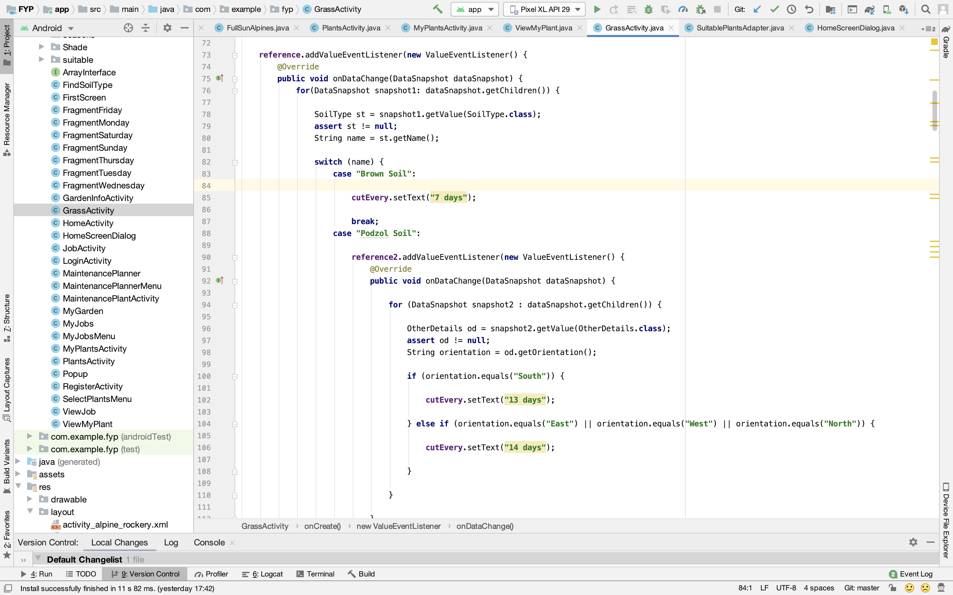

**Calendar Screens**

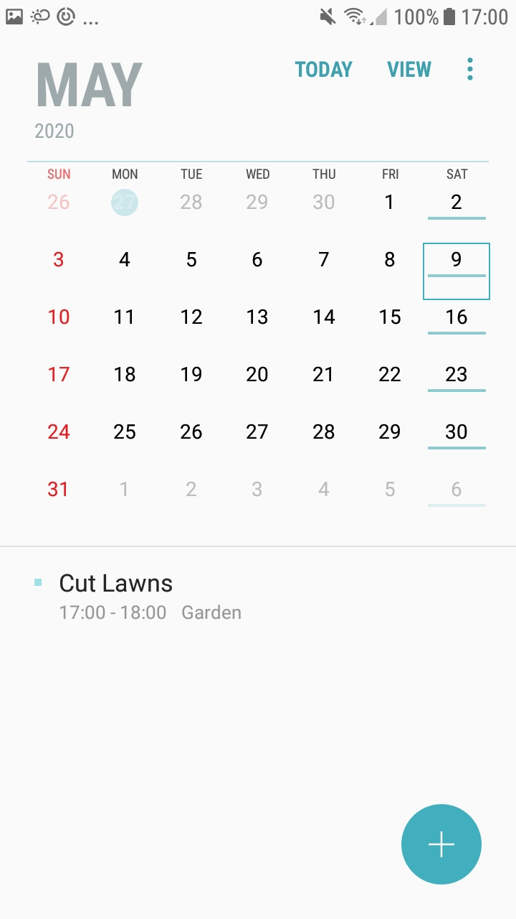

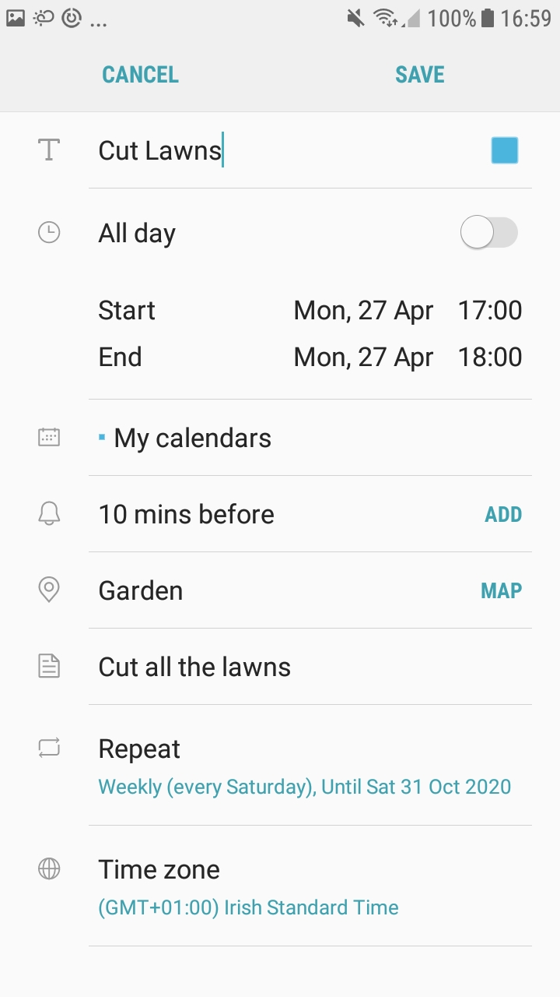

When the button is pressed and the calendar app opens up, all the user has to do is press save. The details have already been input through an intent from the app.

GardenPal uses an algorithm to input these details into the calendar. In the example above, the app has decide that the user should cut grass every 7 days.

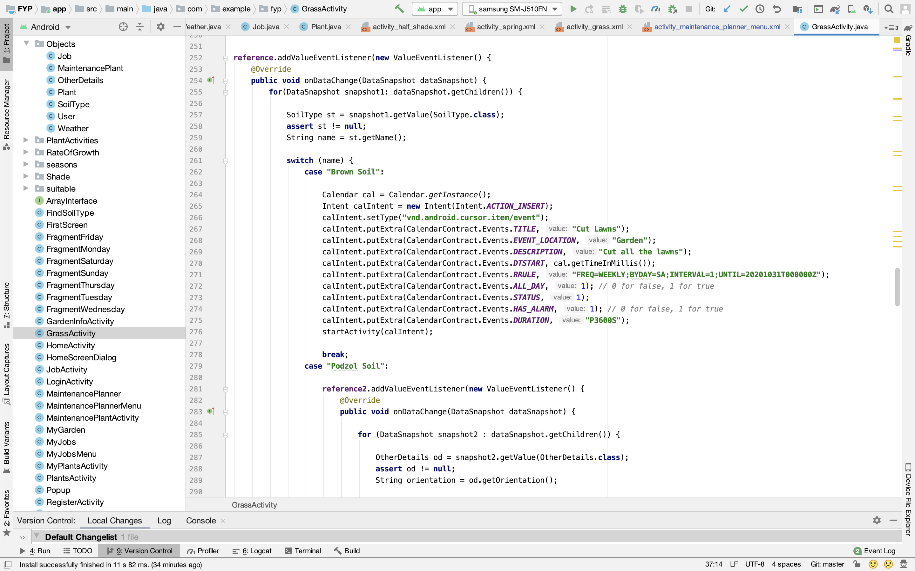

**Select a Time Screen**

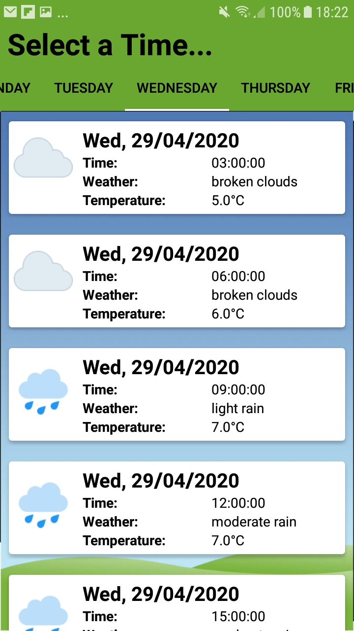

When the user clicks the ‘Create a Job’ button they are forwarded to this screen where they can view the weather forecast for 5 days into the future. The user can select which day that suits them from the tabs at the top and select a time.

The weather data comes from the openweathermap API and is parsed using volley.

**Parsing Weather data**

To get the weather data I used the openweathermap API, which allowed me to get the weather forecast for 5 days into the future at 3 hour intervals. Ideally, I would have liked to have it at 1 hour intervals but I would have had to pay for that.

Firstly, GardenPal gets the users location using google location services.

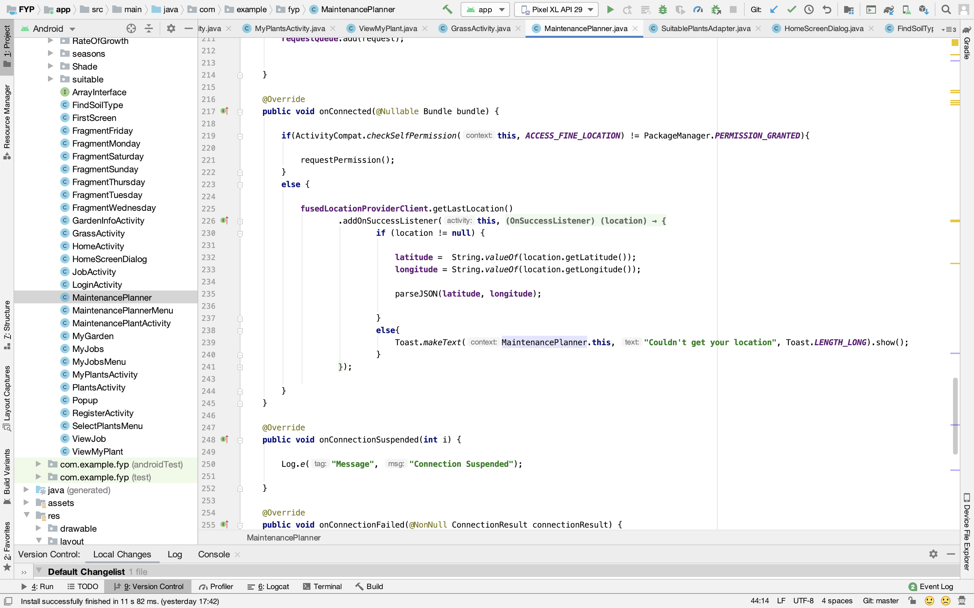

This method gets the longitude and latitude of the user’s phone and then passes them into the method that parses the weather data. This method **parseJSON** takes in 2 strings as parameters (longitude and latitude).

In the parseJSON method the 2 parameters are passed into the URL of the API.

String url = **"https://api.openweathermap.org/data/2.5/forecast?lat="** + la + **"&lon="** + lo + **"&APPID=43ef55f9e03de2e95cc48537a99240ec"**;

This URL gets weather data based on longitude and latitude and by passing the users longitude and latitude it means the weather data that they receive highly accurate.

I would have rather the user input their Eircode and the app could pass that Eircode into the URL but unfortunately this was not possible.

This method then parses through the weather data and adds them to Arraylists based on the day of the week.

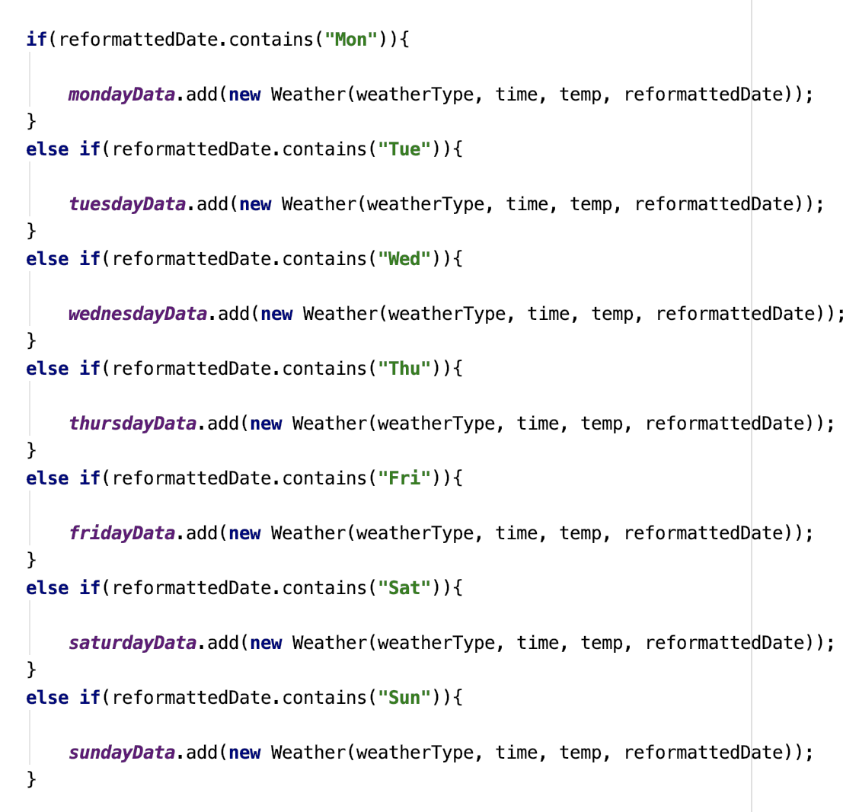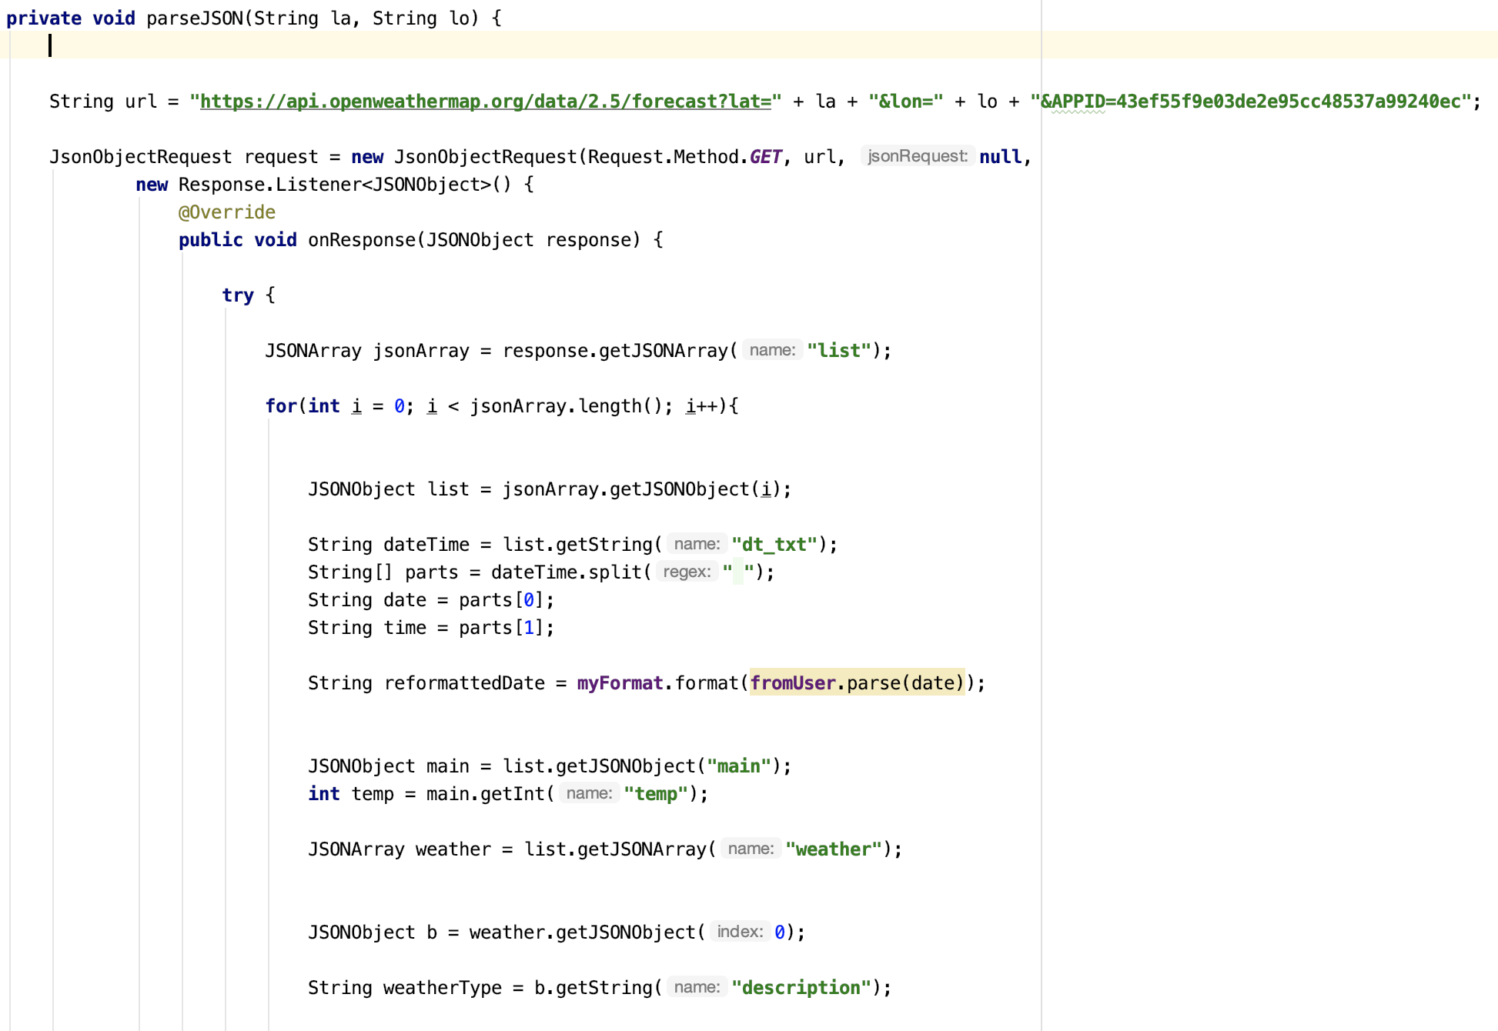

Each day of the week has its own fragment within the ‘Select a time’ screen.

Each fragment is populated by the Arraylist matching that fragment.

e.g. Monday Fragment is populated with the Monday Arraylist.



And this is how the fragments are populated…

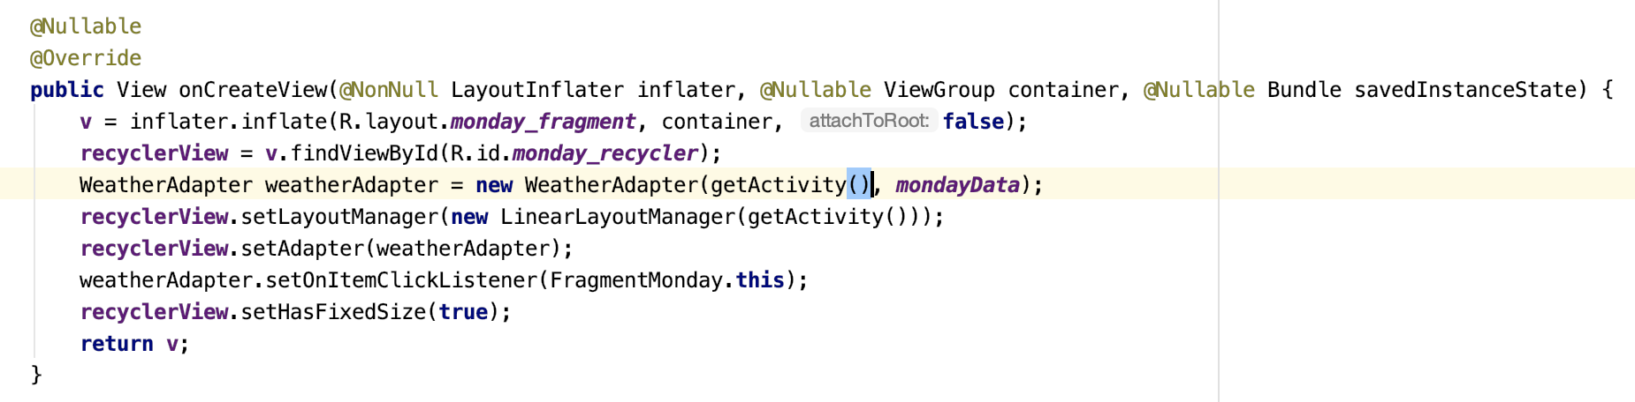**Create a Job Screen**

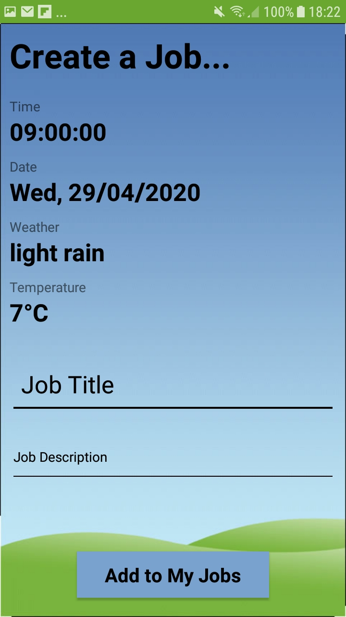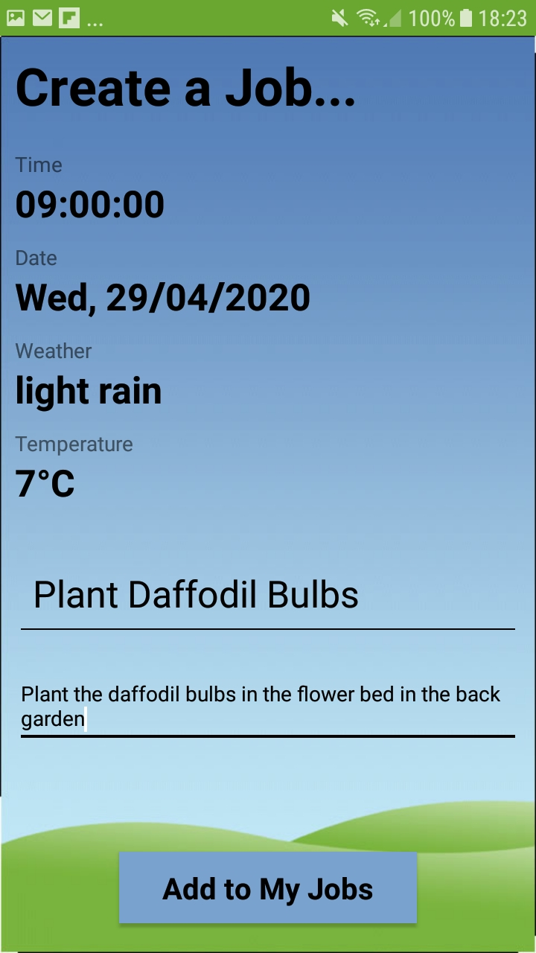

When the user picks a time that suits them, they are brought to page where they can see the details of the time they have selected and input the job title and the description of the job, like above.

After the user has finished filling out the details they can click the ‘Add to My Jobs’ button the job will be add to the section ‘Created by Me’ in ‘My Jobs’.

**Plant Maintenance Screen**

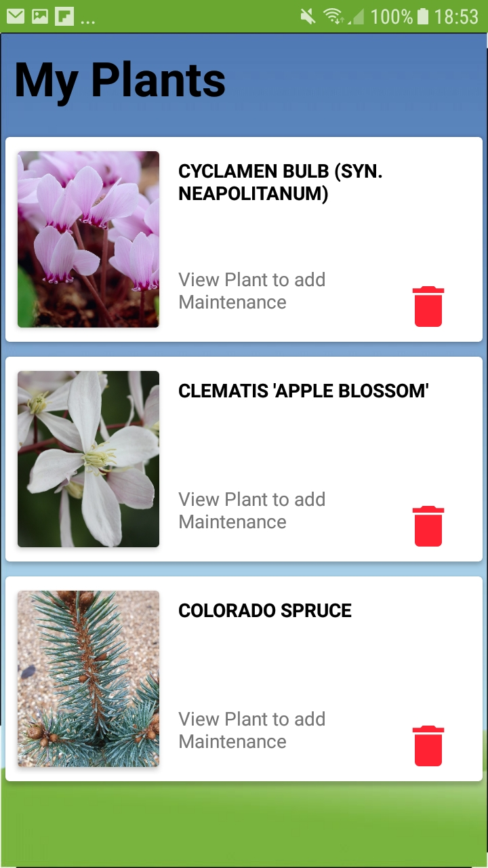If the user clicks on ‘Plant Maintenance’ they are forwarded to ‘My Plants’ where they can, like before, click into one of their plants and add that plant to ‘My Jobs’ and GardenPal will automatically decide when to set maintenance for that plant.

This is the exact same screen as before, so all the user’s plants that they have added will be here.

**My Jobs Menu Screen**

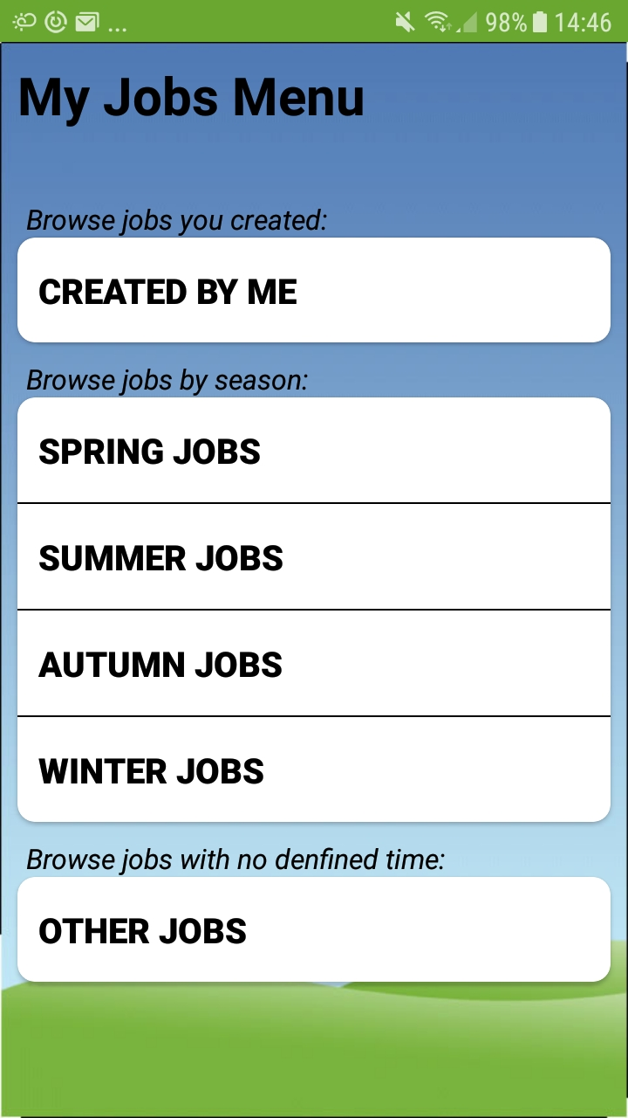

This is the ‘My Jobs’ menu.

**Browse jobs you created:** In this menu option, the user can browse all the jobs they have created in the ‘Created a job’ section from Maintenance Planner.

**Browse jobs by season:** When the user clicks the ‘Add to My Jobs’ button on one of their plants it will appear in one of these menu options.

**Browse jobs with no defined time:** When the user clicks the ‘Add to My Jobs’ button on one of their plants and there is no specified time for maintenance then the plant will appear here as a job.

**Jobs Created by Me Screen**

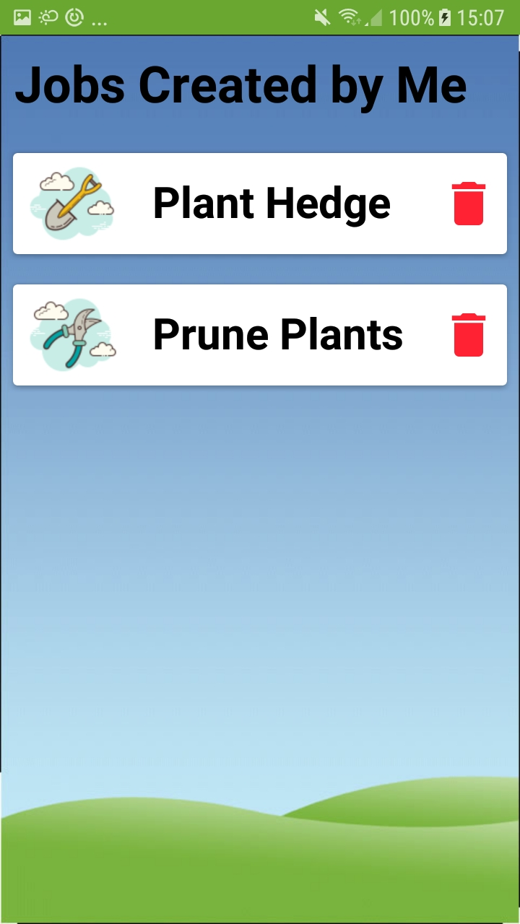

All the jobs the user has created themselves will appear here. The user can delete a job if they have completed it by tapping the red bin button.

To get all the jobs the user has created, a query is sent to the database looking for all the jobs associated to the current user.

**reference** = FirebaseDatabase.*getInstance*().getReference().child(**"Job"**).child(**user**.getUid());

**View My Job Screen**

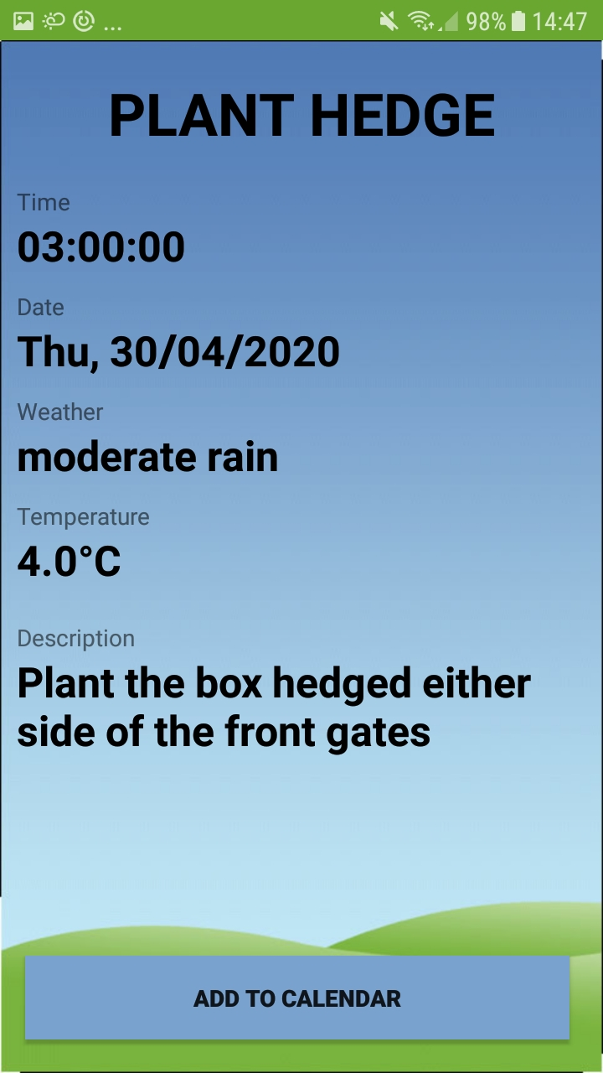

When a user clicks on one of their jobs they are brought to this screen where they can view all the details about that job. If they wish they can add the job to the calendar on their phone. This will be explained in more detail on the next page…

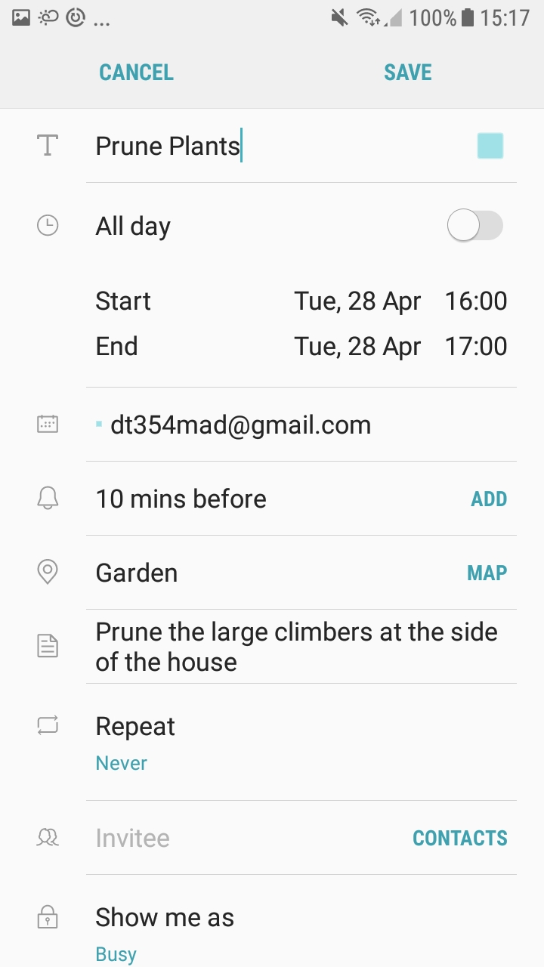When the user clicks the ‘Add to Calendar’ button, they brought to the calendar on their phone. The title, description and date has all been input already, all the user has to do is press save and the create will be created.

This process is done through intent, which is displayed below

The date id split into 3 parts, day, month and year and then passed into a GeogorianCalendar object and passed into the calendar app.

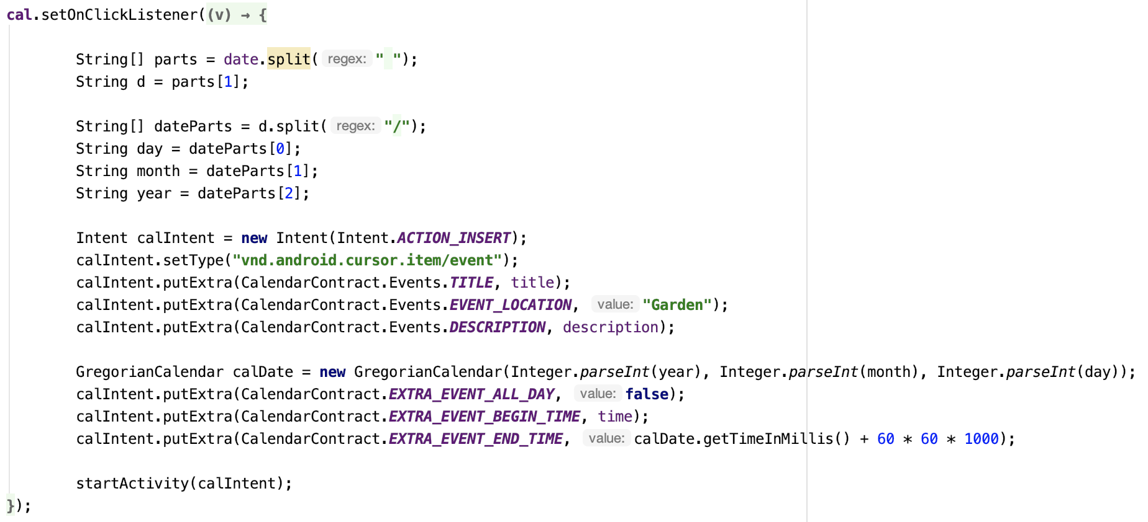

**Seasonal Jobs Screen**

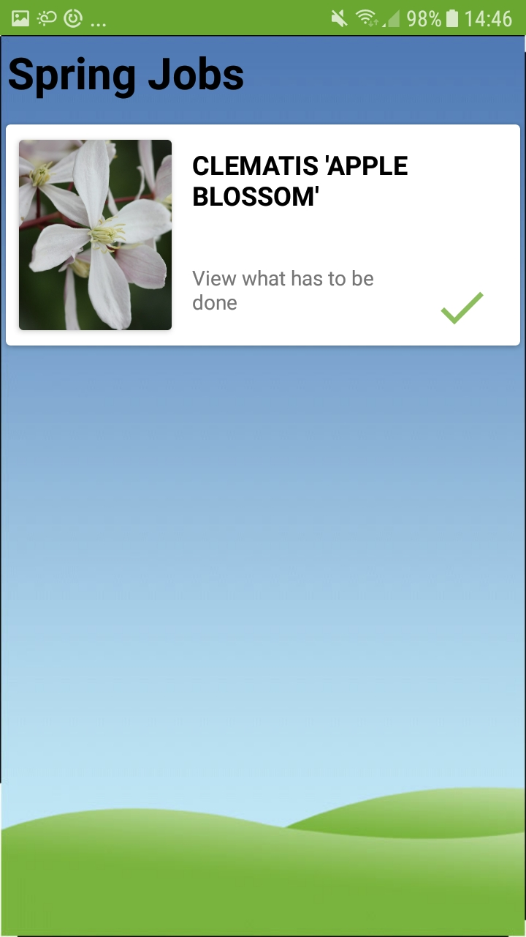

When the user clicks on either Spring Jobs, Summer Jobs, Autumn Jobs, Winter Jobs they are brought to a screen like this. So, in this screen all the jobs the user has to do in Spring will be here.

This activity is populated by the Spring Arraylist as it the Spring Jobs screen.

The user can click into a job and view what has to be done or if they have completed the job they can click the green tick to remove the job from the list.

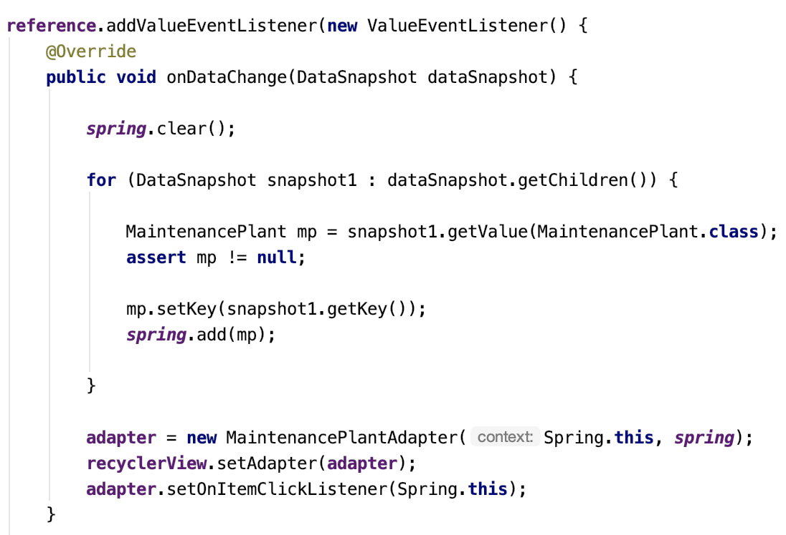

**View Plant Job Screen**

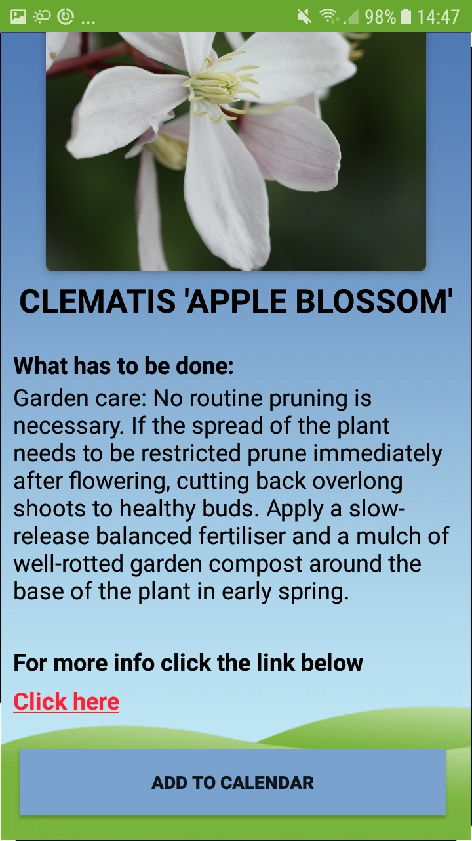

When a user clicks into one of their jobs to view it, they see what has to be done and a hyperlink.

If the user wants to view more information on taking care of the plant they can click on the red link. It will open up a web browser where they can view more information. GardenPal opens the browser using an intent like so…

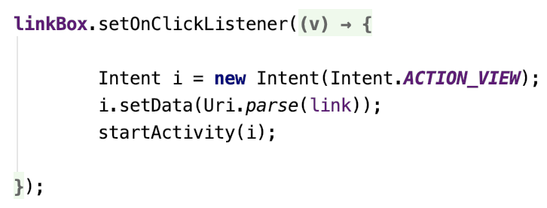

The user can also click the ‘Add to Calendar’ to add the job to their calendar, this works in the same way as before.

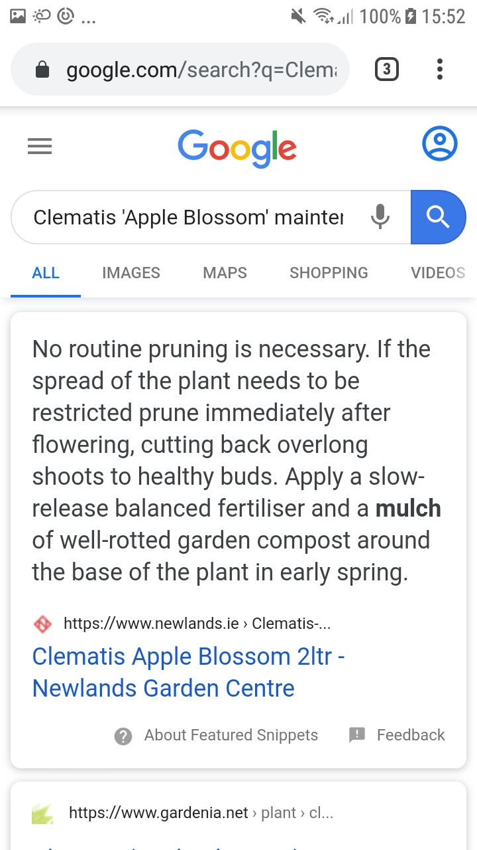

This the web page that will open when the user clicks the link.

**Other Jobs Screen**

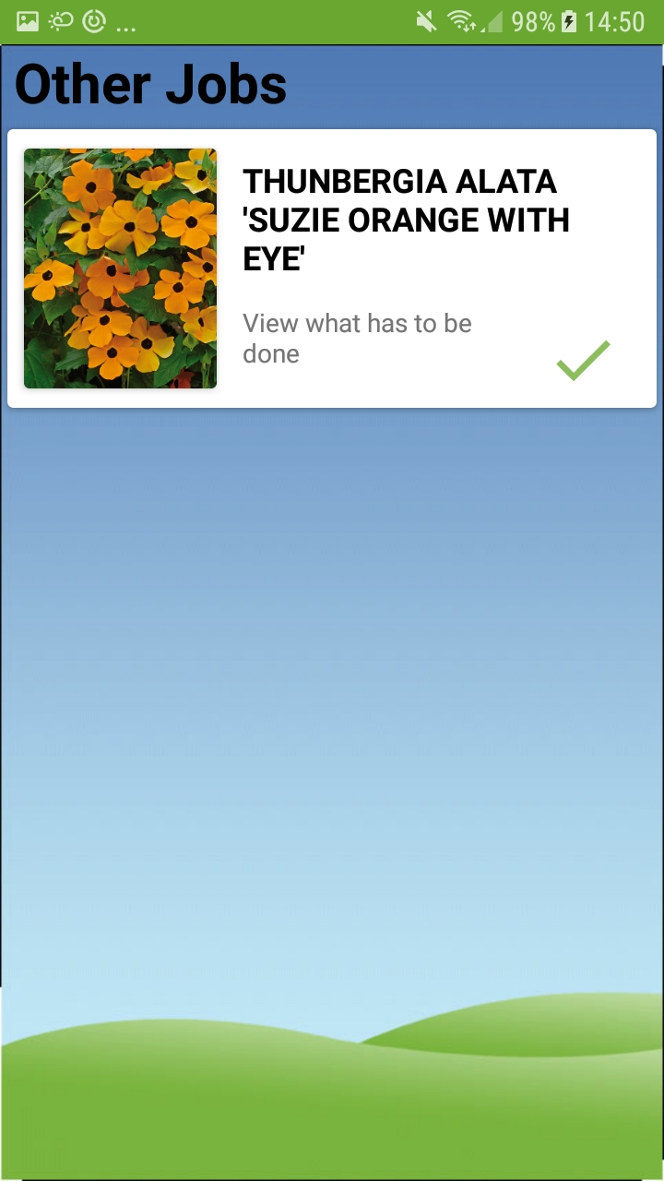

This screen displays all the user’s jobs that have no specified time. It is the same as the seasonal job screens. The user can click to the view the job in the same way as before and remove a job by clicking the green tick.

**Implementation Issue and Resolutions**

The main issue I had for a long time was parsing the weather data. I originally wanted to use the Met Eireann weather API as it was more local and I could get a longer weather forecast from it. The problem with was the fact that the data was in XML format which was too awkward to parse in Android Studio. Eventually I moved onto the openweathermap API which is in json format and much easier to parse.

Another big issue I has was getting the algorithm for recommending plants right. I had to constantly change it and tweak it to make it as accurate as possible.

A minor issue I had was getting the images for the plants to display. I kept getting errors that they were too large and I researched into the issue and could never some up with a solution. Eventually I continued on without them working and realised that I had made an error while parsing the plants from the json files.

I had a major issue trying to find good plant data. Any API’s that I found where either too large are too complicated to understand. In the end, I found a website with the data I wanted. I used a web scraper to store the data in json files and parsed those json files in Android Studio.

**Test Plan**

|  |  |  |  |
| --- | --- | --- | --- |
| **Test Case** | **Expected Result** | **Actual Result** | **Pass/Fail** |
| User clicks the Login button | User is directed to the Login Screen | As Expected | Pass |
| User clicks the Registration button | User is directed to the Registration Screen | As Expected | Pass |
| User tries to login in with no email | Error thrown | As Expected | Pass |
| User tries to login in with no password | Error thrown | As Expected | Pass |
| User tries to login in with wrong email | Error thrown | As Expected | Pass |
| User tries to login in with wrong password | Error thrown | As Expected | Pass |
| User tries to login with no internet connection | Error thrown | As Expected | Pass |
| User clicks the ‘Not Registered? Sign up’ button | The user is redirected to the registration screen | As Expected | Pass |
| User clicks sign in button with correct details | The user is directed to the home screen | As Expected | Pass |
| User tries to register with an invalid email format | Error thrown | As Expected | Pass |
| User creates password with a space | Error thrown | As Expected | Pass |

|  |  |  |  |
| --- | --- | --- | --- |
| User creates a password with less than 7 characters | Error thrown | As Expected | Pass |
| Users passwords don’t match | Error thrown | As Expected | Pass |
| User tries to register without a first name | Error thrown | As Expected | Pass |
| User tries to register without a last name | Error thrown | As Expected | Pass |
| User clicks on the ‘Already have an account? Sign in here’ button | User is redirected to the login screen | As Expected | Pass |
| User clicks the register button with correct details | User is directed to the home screen and a pop up appears | As Expected | Pass |
| User clicks the ‘take me there’ button | User is directed to the Edit Garden Details screen | As Expected | Pass |
| User clicks the finish button | The user is presented with a popup | As Expected | Pass |
| User clicks ‘yes’ in the popup | User is directed to the Add Plants Menu | As Expected | Pass |
| User clicks ‘no thanks’ in the popup | Garden details are updated and pop up disappears | As Expected | Pass |
| User clicks ‘I’ icon in top right of home screen | User is presented with a popup | As Expected | Pass |

|  |  |  |  |
| --- | --- | --- | --- |
| User clicks anywhere on the screen when popup is open | Popup disappears | As Expected | Pass |
| User clicks Maintenance Planner button | User is directed to the Maintenance Planner menu | As Expected | Pass |
| User clicks Grass Planner button | User is directed to the Grass Planner Screen | As Expected | Pass |
| User clicks Create a Job button | User is directed to the Select a time screen | As Expected | Pass |
| User clicks Plant Maintenance button | User is directed to the My Plants screen | As Expected | Pass |
| User clicks Add to Calendar button | Calendar app opens | As Expected | Pass |
| User clicks on a day from the tab layout | The weather data for that day is displayed | As Expected | Pass |
| User clicks on a time | User is directed to the Create a Job page | As Expected | Pass |
| User clicks Add to My Jobs without filling in the title or description | Error thrown | As Expected | Pass |
| User clicks Add to My Jobs with all fields filled in | The job is created and add to the user jobs | As Expected | Pass |
| User clicks on one of their plants | The user is directed to the View Plant screen | As Expected | Pass |

|  |  |  |  |
| --- | --- | --- | --- |
| User clicks Add to My Jobs button | A job is created for the plant and added to My Jobs | As Expected | Pass |
| User clicks the red bin button on one of their plants | The plant is removed from the list of the user’s plants | As Expected | Pass |
| User clicks on the ‘Recommended for you’ menu option | User is directed to the Recommended Plants Menu | As Expected | Pass |
| User clicks on the ‘Full Shade’ Menu option | User is shown a list of plants that require full shading | As Expected | Pass |
| User clicks on the ‘Partial Shade’ Menu option | User is directed to the Partial Shade Menu | As Expected | Pass |
| User clicks on the ‘Full Sun’ Menu option | User is directed to the Full Sun Menu | As Expected | Pass |
| User clicks on the ‘Conifers’ Menu option | User is presented with a list of Conifer plants | As Expected | Pass |
| User clicks on the ‘Alpines and Rockeries’ Menu option | User is presented with a list of Alpine and Rockery plants | As Expected | Pass |
| User clicks on the ‘Bedding’ Menu option | User is presented with a list of Bedding plants | As Expected | Pass |
| User clicks on the ‘Climbers’ Menu option | User is presented with a list of Climber plants | As Expected | Pass |
| User clicks on the ‘Exotics’ Menu option | User is presented with a list of Exotic plants | As Expected | Pass |
| User clicks on the ‘Ferns’ Menu option | User is presented with a list of Fern plants | As Expected | Pass |

|  |  |  |  |
| --- | --- | --- | --- |
| User clicks on the ‘Grasses’ Menu option | User is presented with a list of Grass plants | As Expected | Pass |
| User clicks on the ‘Hedges’ Menu option | User is presented with a list of Hedges plants | As Expected | Pass |
| User clicks on magnifying glass | Search bar appears | As Expected | Pass |
| User types into search bar | Plants matching the users text appear | As Expected | Pass |
| User clicks the ‘+’ sign on a plant | The plan is added to the users list of plants | As Expected | Pass |
| User clicks on a plant | User is directed to a page to view that plant | As Expected | Pass |
| User clicks Add to My Plants | The plant  Is added to the users list of plants | As Expected | Pass |
| User clicks on the Created by Me menu option | User is shown a list of jobs they have created | As Expected | Pass |
| User clicks on the Spring Jobs menu option | User is shown a list of plants that require maintenance in Spring | As Expected | Pass |
| User clicks on the Summer Jobs menu option | User is shown a list of plants that require maintenance in Summer | As Expected | Pass |
| User clicks on the Autumn Jobs menu option | User is shown a list of plants that require maintenance in Autumn | As Expected | Pass |
| User clicks on the Winter Jobs menu option | User is shown a list of plants that require maintenance in Winter | As Expected | Pass |
| User clicks on the Other Jobs menu option | User is shown a list of jobs at don’t have a specified time | As Expected | Pass |
| User clicks on red bin button on a job | Job is the deleted from the users list of jobs they created | As Expected | Pass |
| User clicks green tick | Job is removed from the user’s seasonal jobs or other jobs | As Expected | Pass |
| User clicks Add to Calendar Button | The calendar app opens | As Expected | Pass |
| User clicks on the ‘Click here’ hyperlink | Web browser opens with the name of the plant and ‘maintenance’ in the search bar | As Expected | Pass |
| User clicks the logout button | The user is logged out of the app and directed to the welcome page | As Expected | Pass |

**Conclusion**

I feel that I have learnt a great deal throughout the year from doing this project. I have never developed something as large as this over such a long period of time. This made me better at time management and how to prioritise work.

I am happy with the way my project turned out. Although I did not get to do everything I set out in the brief I feel that the app fulfils it true purpose, which is to help people with gardening. If there is one thing I wish I had done, it would be the forum. I feel that a forum where the users could go to get help from other gardeners or give people advice would have added a huge benefit to the users of the app.

I am especially proud of the UI. I put a lot of time in making the UI easy to use and aesthetically pleasing.

Looking back, I think I could benefitted greatly from using a product management software such as JIRA which I used during my internship in 3rd year. I believe it would have helped greatly in terms of time management and prioritising tasks.

Overall, the experience of developing this app was an incredible learning experience and will in no doubt stand to me during my career. I thoroughly enjoyed every minute of it.